

Machine Learning
Module Code -ME7026

 | SCHOOL OF ENGINEERING DEPARTMENT OF MECHANICAL ENGINEERING
Coursework Assessment Brief

Module Code |  | ME7026
Module Title |  | Machine learning
Title of Assessment |  | Fault classification in Robot Joints
Assessment set by (and contact) |  | Dr Olga Duran  o.duran@kingston.ac.uk
Group Member’s Info

K2445563 | : : | JOSHVA JONATHAN JOSEPH
K2441768 | : | OMKAR ANANT JOSHI
K2454461 | : | SARATH KUMAR KOMATHUKATTIL
K2447273 | : | RAHUL RADHAKRISHNA MENON

Table of Contents

Introduction 4
PART I –Load and overview data 4
PART II – Clustering 6
PART III –Classification: Training and Testing 16
PART IV – Classification using Neural Networks 29
References 41
Appendix-MATLAB Codes 42
Fault classification in Robot Joints- Matlab Codes 42

Introduction
This report section underscores the crucial role of understanding the data and its characteristics in the initial steps of loading, exploring, and preparing the Fault Detection in Hexapod Robot Joints dataset for subsequent machine learning tasks, specifically clustering and classification. This understanding ensures that the data is in a suitable format for the chosen algorithms. The primary goal is to create four distinct datasets from the original data, tailored for binary and multiclass classification tasks, and consider smaller sample sizes for efficiency and experimentation.

PART I –Load and overview data
Dataset Loading and Initial Inspection
The dataset, 'Hexapod_One_Joint_data_set-1.csv', was meticulously loaded into the MATLAB environment. It was immediately and thoroughly inspected upon loading to determine its overall structure, data types, and potential issues, such as missing values or inconsistencies. The dataset comprises 17,955 samples, each characterized by 9 features, with an additional column representing the class label.
The features include:
- X, Y, Z: Representing spatial coordinates, likely related to the joint's position or movement in three-dimensional space.
- Slop (x), slop(x/z), slop(1/z), slop(1/x), slop(z/x), slop(z): These features are derived from the spatial coordinates, potentially representing slopes or rates of change in different directions or combinations.
- Label: The target variable indicates each sample's fault type or condition.
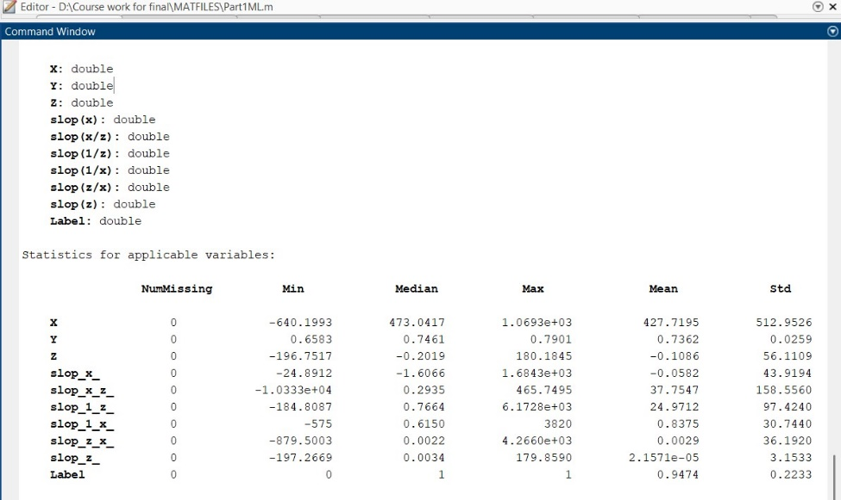 | 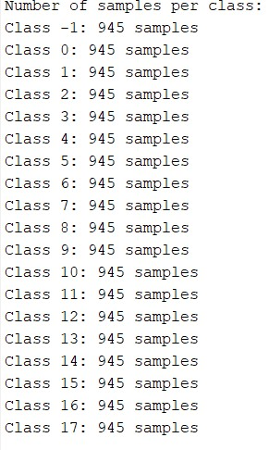
Hexapod dataset summary

- Each class has an equal number of samples (945)
This balance is beneficial for training machine learning models as it prevents bias towards any class, enhancing the model's performance. The label variable represents the condition of the joints, 0 represents fault in first joint,1 represent fault in 2nd joint and so on, increasing sequentially up to 17, whereas -1 represents all joints are fault free.
Data Preparation: Creating the Four Datasets
The given Hexapod Joint dataset is used to generate the following four datasets:
a) Binary Output (Fault/No Fault) Dataset:
This dataset was created to simplify the classification problem into a binary task: fault versus no fault. The original 'Label' column, with distinct classes, was transformed into a binary label. This was achieved by categorising one class as 'Non-Faulty Cases'(0) and grouping the remaining classes into a single 'Faulty Cases'(1) category. These resulted in a dataset with two classes:
- Non-Faulty Cases: 945 samples
- Faulty Cases: 17,010 samples
The resulting dataset, named 'binaryData', consists of 17,955 rows and 10 columns (9 features + 1 binary label). This represents highly imbalanced dataset, with significantly more faulty than non-faulty cases. This factor must be considered when clustering and training classification models in subsequent parts of the assignment. Strategies such as oversampling the minority class or under sampling the majority classes can be used.
b) Multiple Classifications for Different Types of Faults:
This dataset preserves the original 19 fault classifications as they were in the original dataset. This dataset is intended for multiclass classification tasks, where the goal is to distinguish between the different types of faults affecting the hexapod robot joint. The dataset is saved to a CSV file named 'multiclass_classification.csv' for further use.
c) Binary Output (1% Random Samples):
A random sample of 1% of the original data was selected to create this dataset. The same binary label transformation as in (a) was applied to this subset, resulting in a smaller dataset with binary fault/no fault labels. The primary purpose of this dataset is to enable faster experimentation and prototyping of machine learning models, particularly during the initial stages of development. The 1% dataset has a similar class distribution to the entire dataset but with significantly fewer samples, making it easier to iterate on model design and parameter tuning. The generated dataset was saved as 'binary_classification_2.csv'.
d) Multiple Classifications (1% Random Samples):
Like (c), this dataset was created by randomly sampling 1% of the original data. However, in this case, the original 19 fault classifications were retained. This dataset provides a smaller, more manageable dataset for experimenting with multiclass classification algorithms.
Statistical Summary
- The number of Missing Values indicates the presence of any missing data points, which could require imputation or removal.
- Minimum and Maximum Values: Provide the range of values for each feature, which can help identify outliers or scaling requirements.
- Median: The middle value in the distribution is less sensitive to outliers than the mean.
- Mean: The average value, providing a measure of central tendency.
- Standard Deviation (or σ): it’s a measure of the spread or variability of the data around the mean.
The statistical analysis produced the following results:
- Absence of Incomplete Data: The data is complete, showing no missing attribute values. This completeness makes the data preprocessing step easier, making imputation techniques unnecessary.
- Diversity of Variables: Unique features have different ranges of values. For example, the 'X' feature ranges from -640.1993 to 1069.3, while the 'Y' feature is limited to a very narrow band of 0.6583 to 0.7901. This difference in the ranges suggests that feature scaling may be critical to counter the influence of features with wider ranges on the learning algorithm.
- Feature Distributions: Analysing the mean and median values, as well as the standard deviation, provides insights into each feature's distribution. For example, a significant standard deviation indicates a broader range of values, while a significant difference between the mean and median suggests an uneven distribution,

PART II – Clustering

K-Means
Binary dataset
Since the dataset provided to us was quite large, and K-means is suitable for distinguishing faulty patterns, we decided to use K-means as our first clustering method. The centroids offer an easy-to-understand representation of the clusters. In this section, our first goal was to apply K-means clustering to all the types of datasets. We started by using K-means clustering for binary dataset.
To determine the optimal number of clusters, we use the Calinski-Harabasz criterion to select the best K value, and the optimum number of clusters was found to be 5.
Applied K-Means clustering using “Correlation” distance as a clustering method and computed cluster centroids to understand the structure of clusters.
We used PCA (Principal Component Analysis) and generated a scatter plot to display the components of clustered data.
`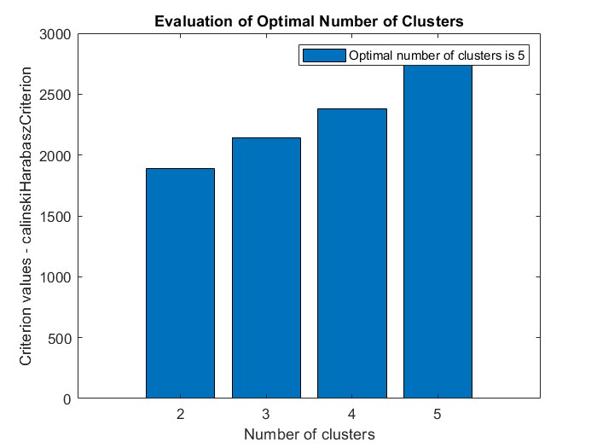 | 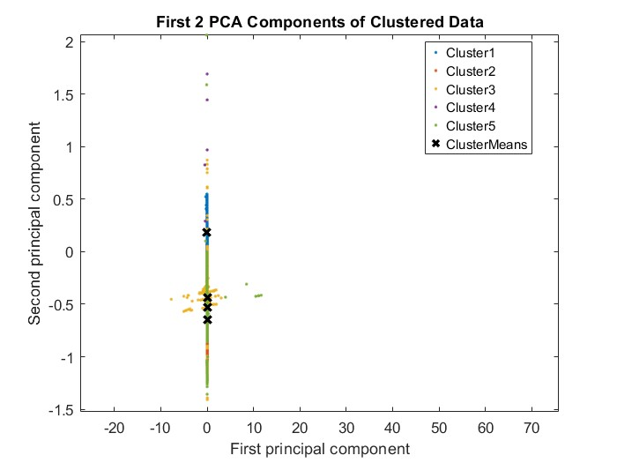

As we can observe, the clustering result does not appear to be very good, there is a significant overlapping of clusters around the centre. Most data points are clustered around the origin, indicating PCA might not be effectively differentiating the clusters.
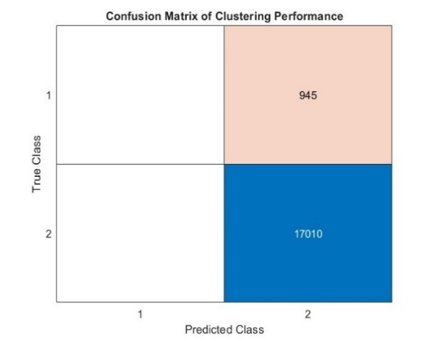 | 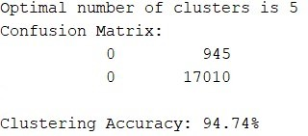

Even though the confusion matrix states that the clustering accuracy is 94.74%, we know that clustering was not good enough. The clustering algorithm performed well in detecting fault cases but completely failed to classify non-faults. The data set imbalances (fault cases significantly outnumbering non-fault cases) might have affected clustering performances, making it harder for the model to form a distinct cluster for the minority classes.
We wanted to overcome the class imbalance issue and improve clustering accuracy by handling class imbalance. The dataset was imbalanced, with faulty cases 1 significantly outnumbering non-faulty cases 0. We tried under sampling the majority class to match the number of non-fault cases by randomly selecting a subset of fault cases to create a balanced dataset. We normalized the balanced dataset as well before applying clustering to get a better result. This time, we tried the Davies-Bouldin Index to evaluate different K values.

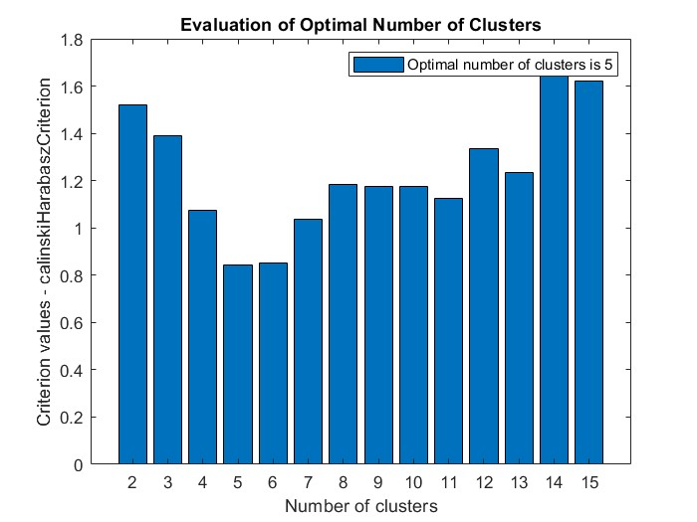 | 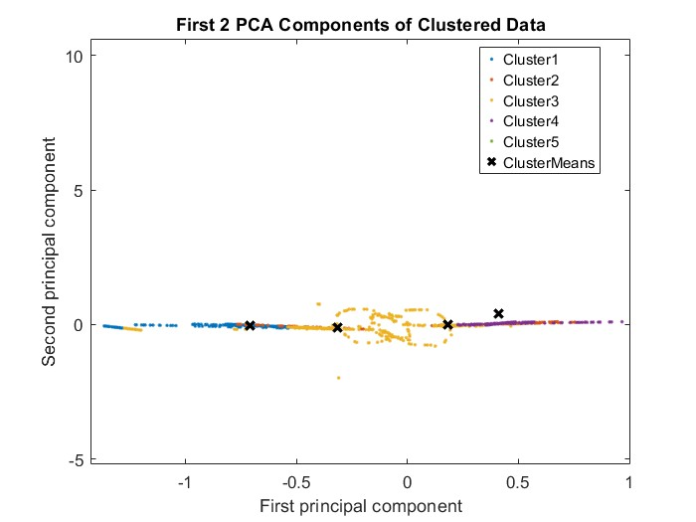

The images indicate some improvement in clustering however, the enhancement is not significant, as we can still see overlapping and most data points aligned in a narrow horizontal band.
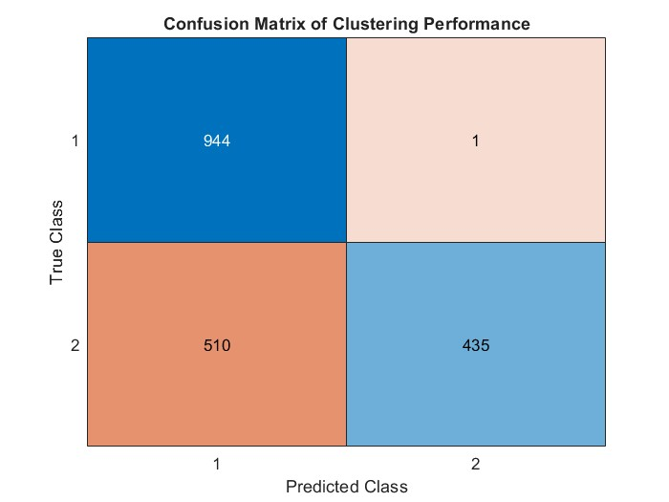 | 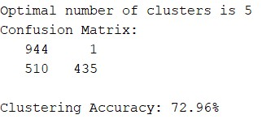

This confusion matrix demonstrates a reasonable separation between faults and non-faults. However, the accuracy is only 74%, indicating that the classification is not entirely precise. Most of the no-fault cases have been correctly classified, while more than 40% of the fault cases have also been correctly identified
As under-sampling alone didn’t give the best results, we tried using the SMOTE function and under-sampling together to balance the dataset.
As we got a better result using the Davies-Bouldin index, we stuck to it as it provides a solid evaluation strategy for choosing the optimum number of clusters, which made clustering more robust and less likely to suffer from over- or under fitting.
Z-score normalisation improved the clustering process, especially when using K means, and we also evaluated the confusion matrix with the ground truth to assess clustering results. This structured approach provided us with the best possible solution for this binary data set by efficiently separating the two different classes.
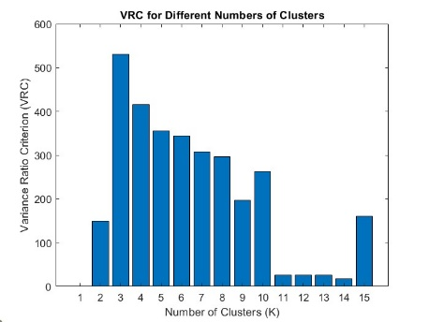 | 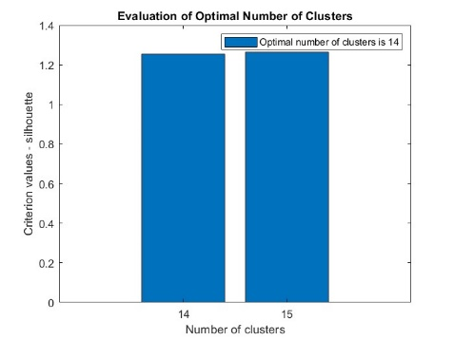 | 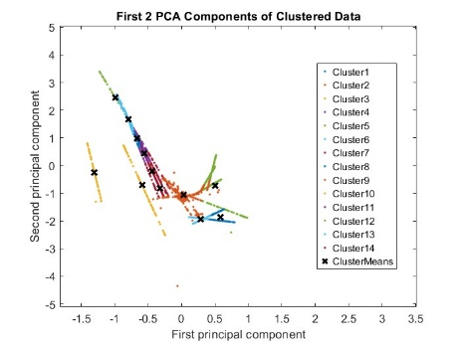

There has been some significant improvement in the clustering results, the clustering appeared to be well structured with minimal overlap and well-positioned centroids. Most clusters appear to be relatively close, suggesting that points within the same cluster are closely packed.
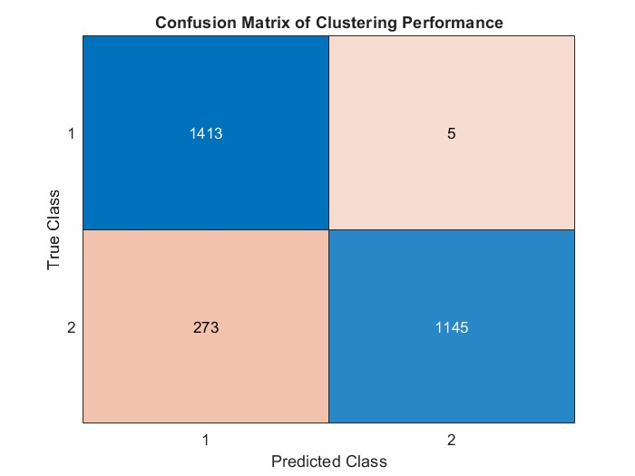 | 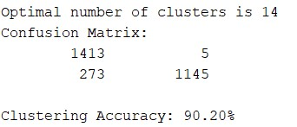

The latest clustering results show a 90% accuracy in distinguishing between faults and non-faults, with a well-separated cluster structure, which is a significant improvement. The selection of 14 clusters has contributed to a more balanced distribution of cases, reducing classification error and enhancing overall clustering performance.
1% Binary dataset
With the same parameter configurations that we used for the Binary dataset, we used a 1% Binary dataset as well, and we achieved good clustering results.
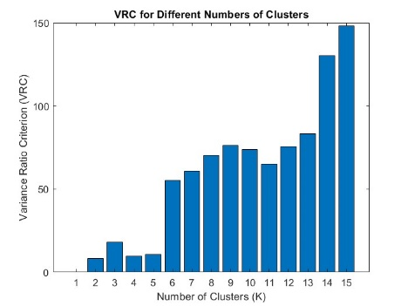 | 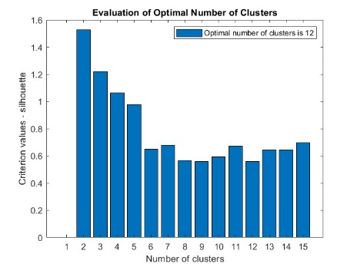 | 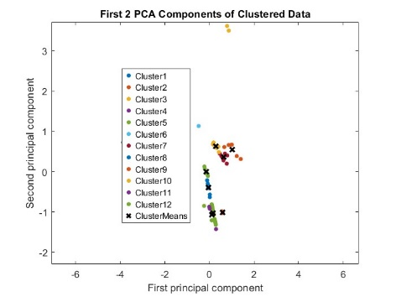

The above three images gives us an overview of optimal clusters and plot graphs of K means clustering.

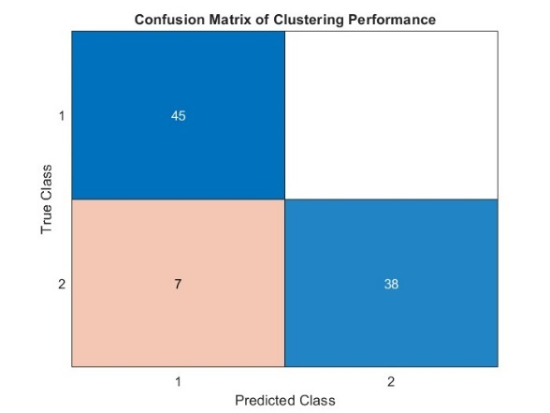 | 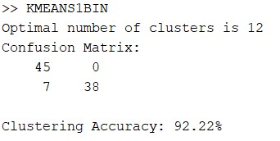

The above confusion matrix shows a good separation between classes with a clustering accuracy of 92.22%.
1%Multiclass dataset
We tried K-means clustering with a multiclass dataset, and we didn’t get good clustering results right away, so we tried normalizing each feature with Z-score, excluding the labels, which prepared the dataset for clustering by scaling it to a standard range, and we visualised both the original and normalized data.
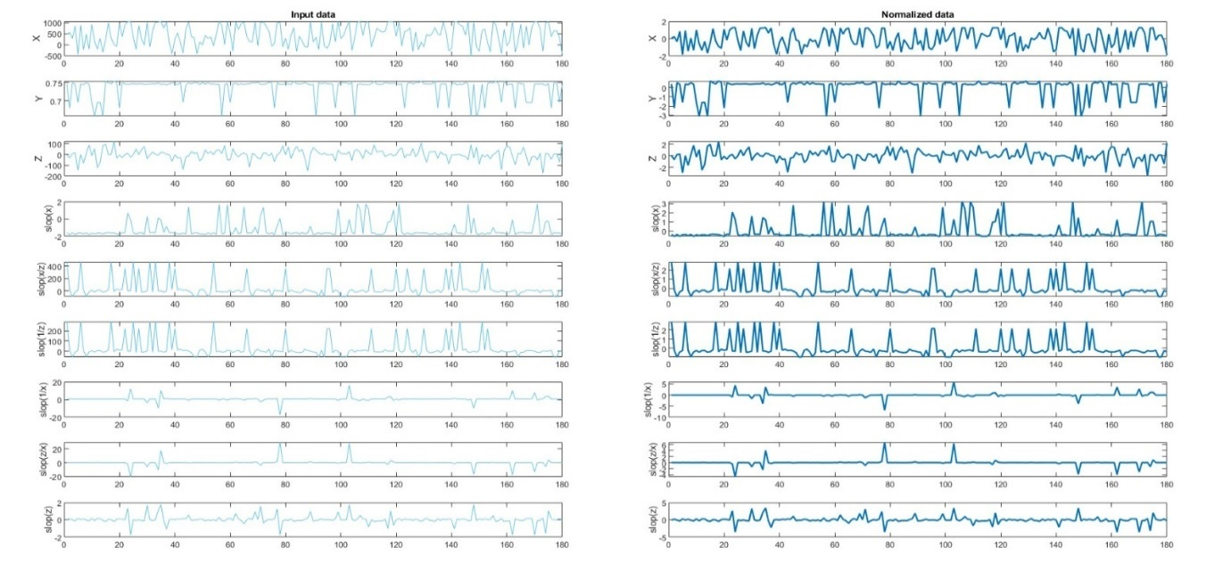

We have tried techniques like PCA to remove noise, which can distort clustering, and we also tried using SMOTE to balance the data. We tried refining clustering algorithm parameters, but we were not able to achieve a good clustering result and tried cluster post-processing as it refines the label mapping process to ensure that the predicted clusters are matched accurately with true labels. We considered using weighted voting to improve label assignments and reduce errors, still there were no improvements in clustering results. We were only able to reach 53.33% clustering accuracy.

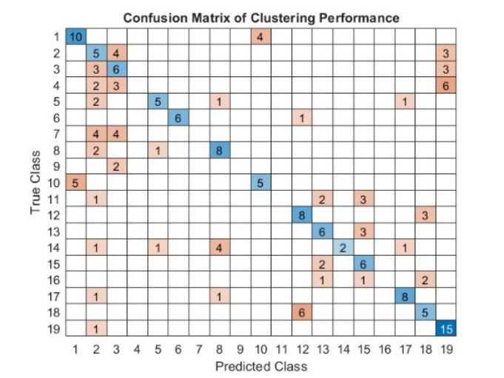 | 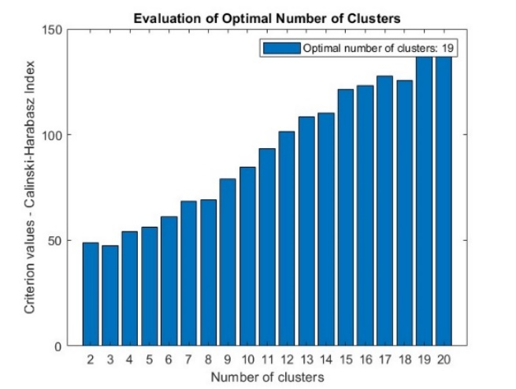

Multiclass dataset
We got even worse results with full multiclass datasets with K-means
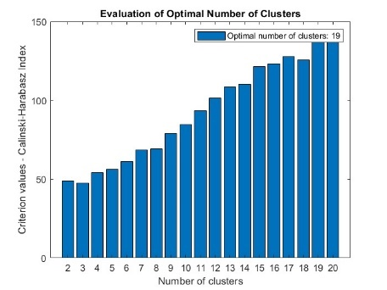 | 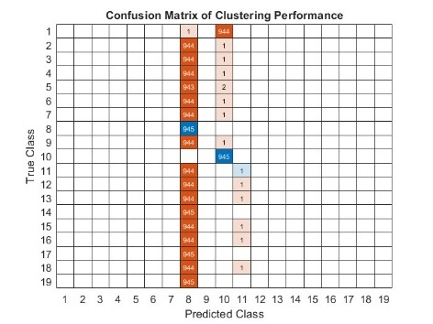 | 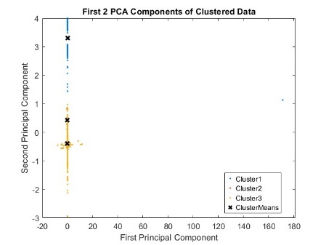

DBSCAN
We opted for DBSCAN as our second clustering algorithm because it is great for detecting faults from irregular patterns, and it also does not require you to specify the number of clusters like K-means. It is great for detecting errors in hexapod robot joints.
Binary dataset
For binary dataset, we started by initial data preparation that is extracting features and labels from the input data separating last columns as labels and remaining columns as features and we use SMOTE to address class imbalance by oversampling the minority classes and under sampling majority classes to ensure equal representation of classes.
Applied Z-score standardisation to features and transformed the data to have zero mean and unit variance. We used the relief algorithm for feature ranking and selecting features based on importance. For parameter tuning, we explored values 0.05 to 1 and tested minimum points 10,15,20,25,30 and used cross-validation to find best parameters.
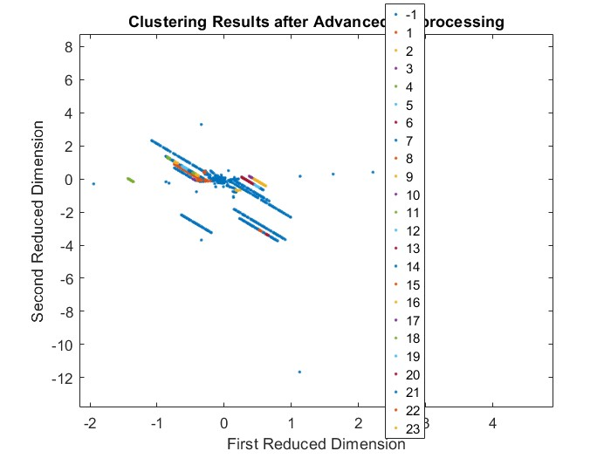
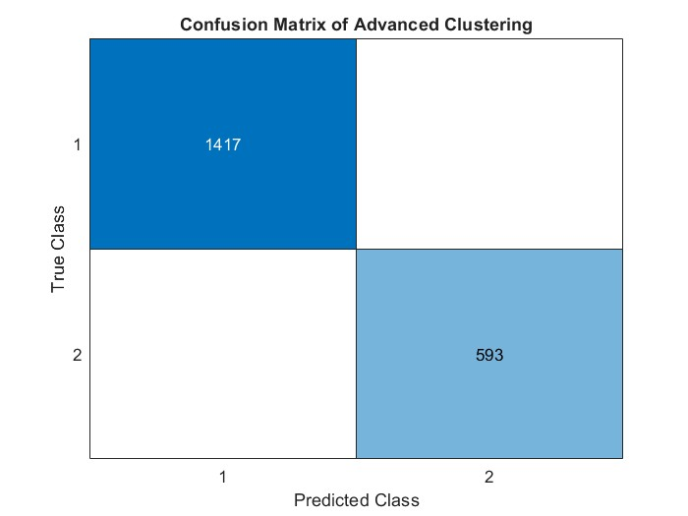 | 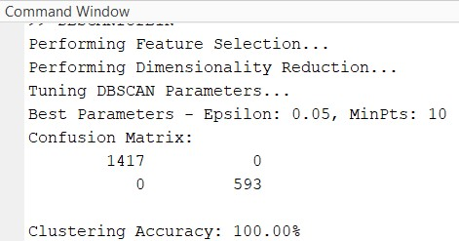

We got a great clustering accuracy of 100% with perfect separation between faults and no-faults.
1% Binary dataset
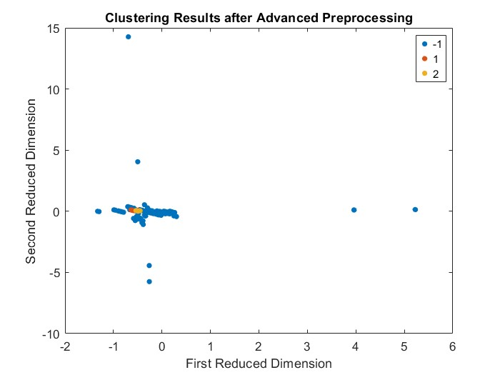
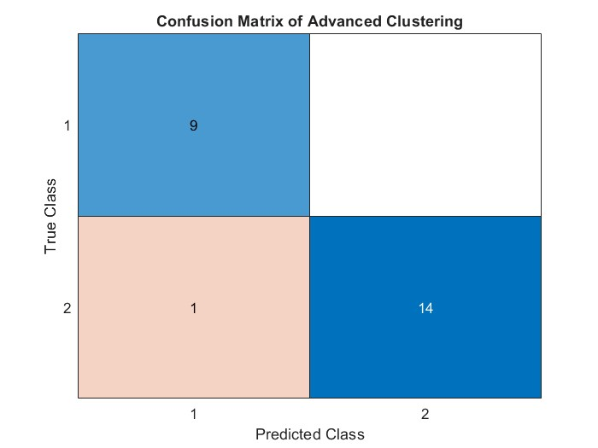 | 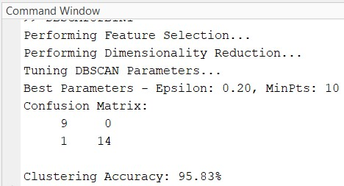

Multiclass Dataset
The multiclass dataset has 19 classes with 945 samples each, there are 18 different types of faults that goes from 0 to 17 and non-fault represented by -1. Since it has multiple classes, it is difficult to classify each and every class perfectly but, the DBSCAN clustering algorithm is a suitable clustering algorithm as it handles multiple classes, and it is most commonly used algorithm to detect faults in robot joints. We used DBSCAN algorithm as follows
We have loaded the features and labels from multiclass data, standardise features using Z-score to normalise the data. Performed PCA and reduced data to top 5 principle components for best clustering efficiency.

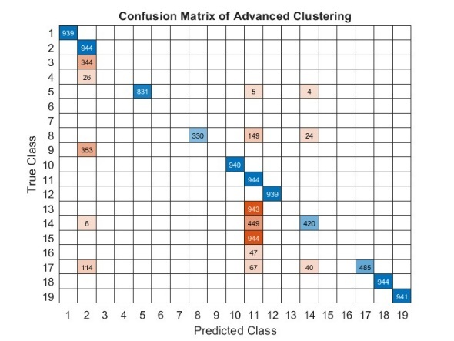 | 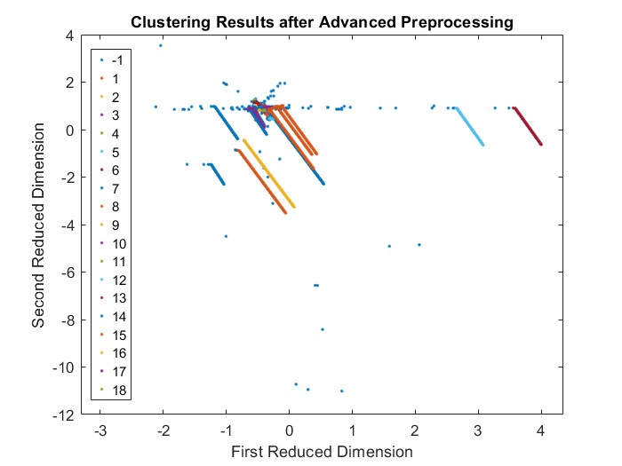

The best accuracy we possibly got was 74% even though there were some good classifications there were also some miss classifications and we found it difficult to make any improvements to the dataset.

1% Multiclass Dataset
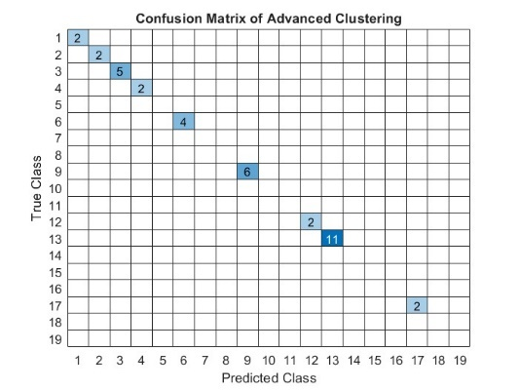 | 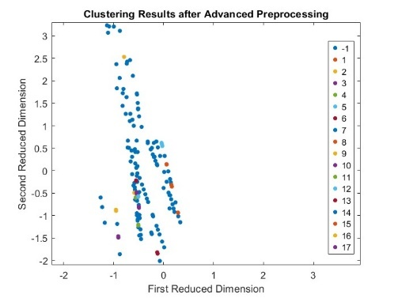

Comparison between two clustering methods.

 | K-Means | DBSCAN
Binary dataset |  | 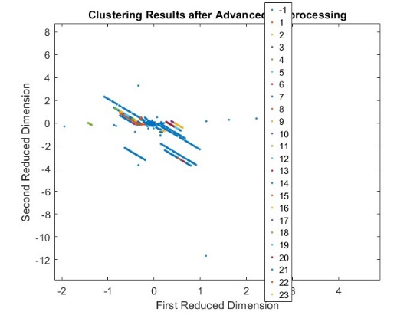
 |  | 
 |  | 
 | For the Binary Dataset DBSCAN provided even better result then K-means Clustering algorithm
1% Binary dataset |  | 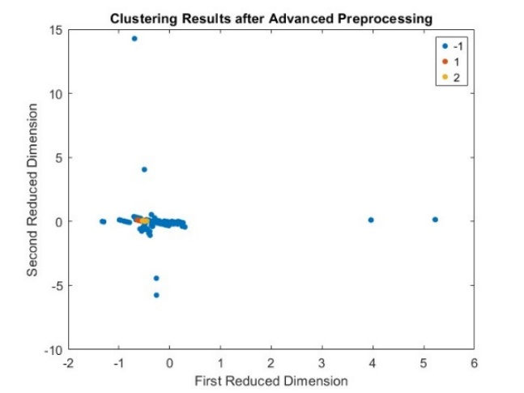
 |  | 
 |  | 
 | For the 1% Binary Dataset DBSCAN provided even better result then K-means Clustering algorithm
Multiset Dataset |  | 
 |  | 
 | For the Multiclass Dataset DBSCAN provided even better result then K-means Clustering algorithm
1% Multiset Dataset |  | 
 | For the 1%Multiclass Dataset K-means provided even better result then DBSCAN Clustering algorithm

Conclusion:
After comparing the confusion matrix of each data set DBSCAN clustering algorithm was found to be the most suitable one for clustering and handling large datasets, it was more reliable and accurate then K-means Clustering algorithm.

PART III –Classification: Training and Testing
Classification for the binary and multiclass dataset is done by using classification learner tool: -
A classification learner is a piece of software or system that automates training, testing, and finding the best classification model for a given dataset. It provides an easy-to-use interface for running, testing, and comparing machine-learning algorithms based on performance metrics.
1)Types of methods attempted
We have explored various classification methods to achieve the best results for this dataset. For both binary and multiclass data, we employed four types of classification techniques. Tree-based models, such as Fine Trees and Boosted Trees, often outperform Linear Support Vector Machines (SVM) and Linear Discriminant Analysis (LDA) (Feldesman, 2002).Tree-based models are effective at capturing complex nonlinear patterns and excel at handling noise and outliers due to their threshold-based splitting mechanism. A key advantage of tree-based classification is its ability to manage imbalanced data by focusing on misclassified samples. Since our dataset is highly imbalanced in a binary format, tree-based classification is the most suitable method
2) Evaluation (Split Data)
Train-Test Split: - 80-20
Metrics used – Accuracy, F1 Score, ROC AUC Score & Confusion Matrix
1.) Binary Data
Binary classification in fault detection aims to differentiate between the fault and no fault in hexapod robot joints and below table gives the results: -
Classification Types | Accuracy | F1-Score | AUC-ROC
Fine tree | 99.99 | 0.8553 | 0.76
Linear SVM | 94.74 | 0.9730 | 0.91
Fine KNN | 99.97 | 1.0000 | 1.0
Boosted Trees | 94.74 | 0.8650 | 0.85

a) Below we will be mentioning the confusion matrix and f1 scores for the two best classification methods used for binary dataset

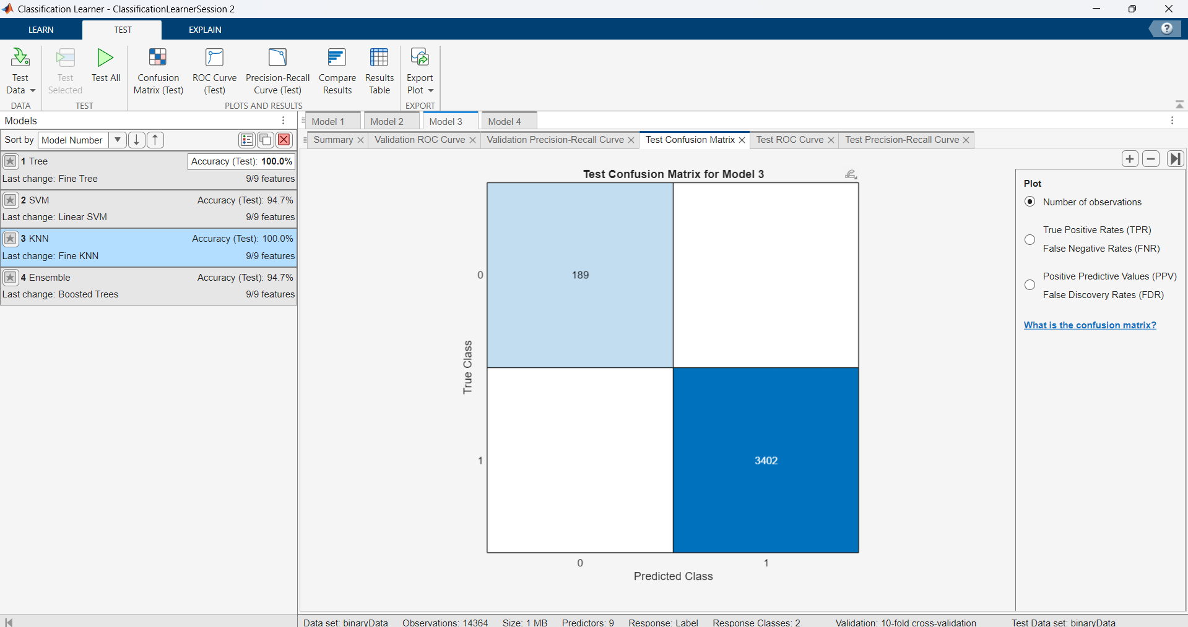  Test Confusion Matrix (Fine KNN) | 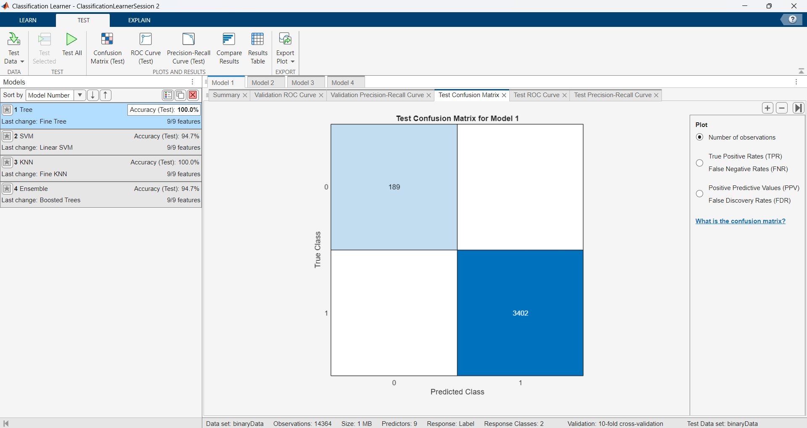  Test Confusion Matrix (Fine Trees)
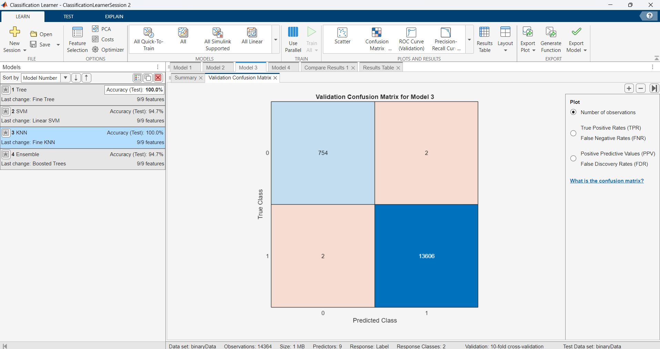  Validation Confusion Matrix (Fine KNN) | 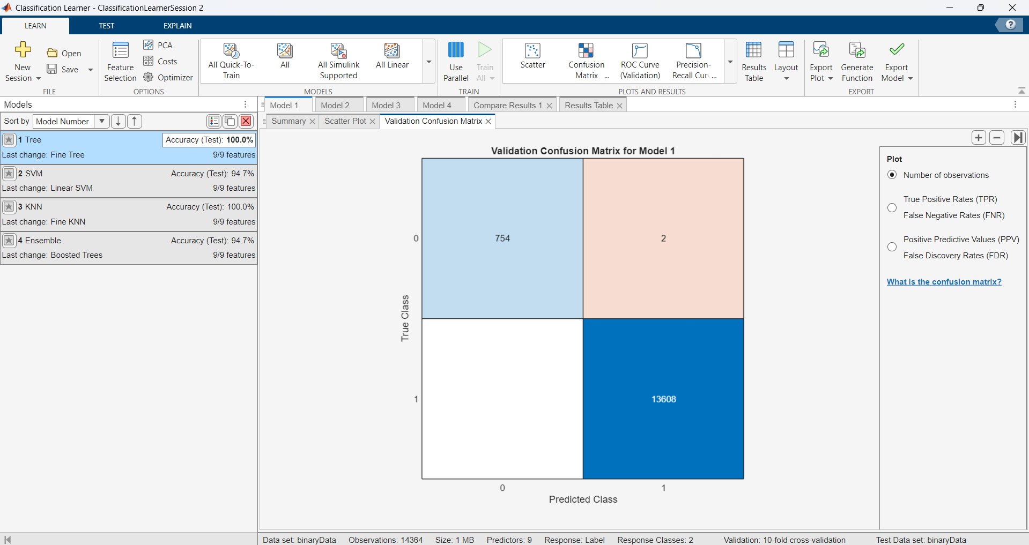  Validation Confusion Matrix (Fine Trees)
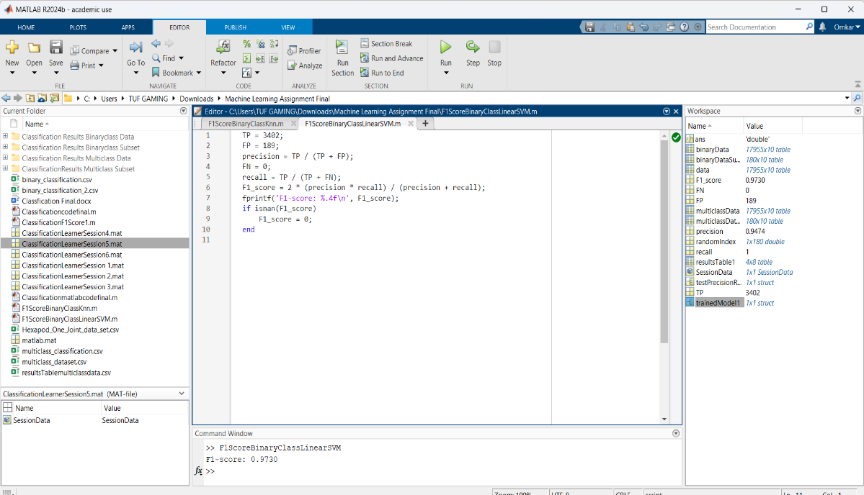  F1 Score (Linear SVM) | 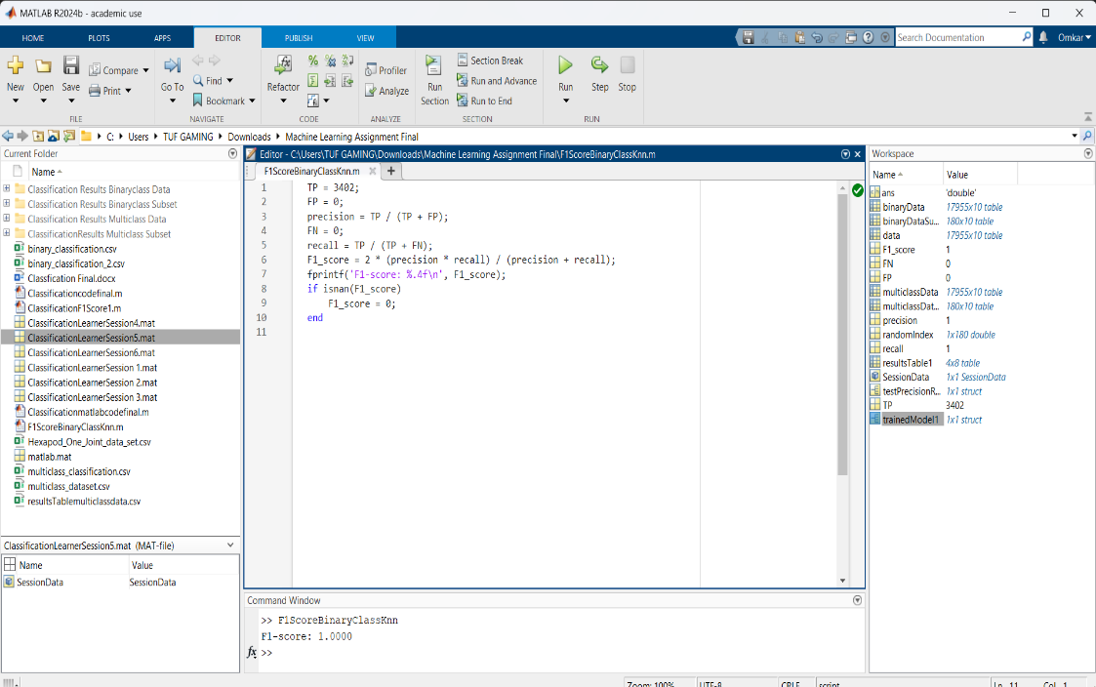  F1 Score (Fine KNN)
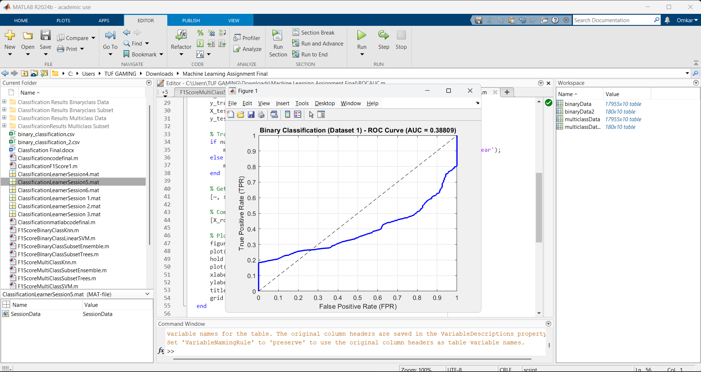
ROC AUC Curve (Binary Data)

Conclusion
From the above results, we can predict that Fine Tree and Fine KNN gives the best classification in comparison with the other two classification methods of the binary data set.

2.) Binary Subset Data
Binary classification in fault detection aims to differentiate between the fault and no fault in hexapod robot joints and below table gives the results: -

Classification Types | Accuracy | F1-Score | AUC-ROC
Fine tree | 100.00 | 1.0000 | 1.0
Linear Discriminant | 91.67 | 0.6532 | 0.67
Fine KNN | 93.07 | 0.7359 | 0.74
Boosted Trees | 93.07 | 0.9640 | 0.92

b) Similarly, we have mentioned the confusion matrix and f1 scores for the two best classification methods used for binary subset dataset
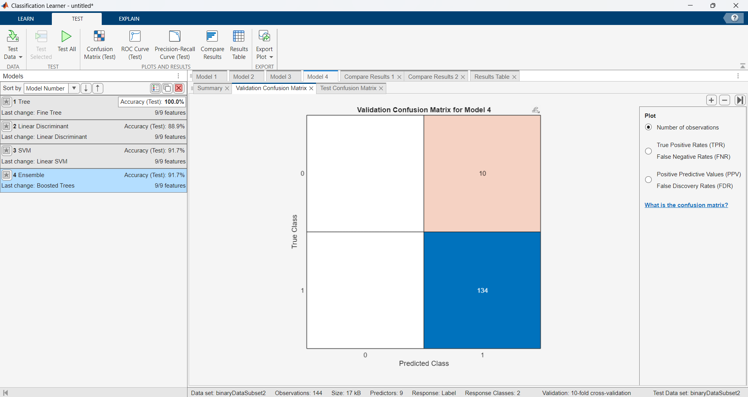  Validation Confusion Matrix (Boosted Trees) | 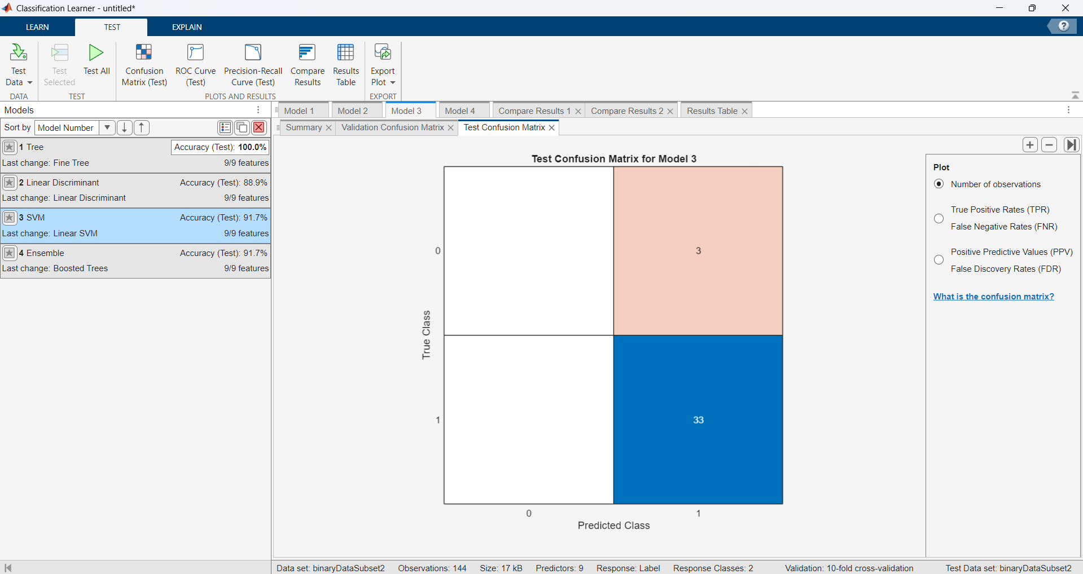  Test Confusion Matrix(Boosted Trees)
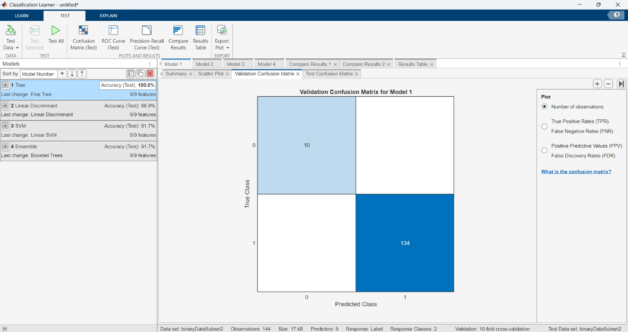  Validation Confusion Matrix (Fine Trees) | 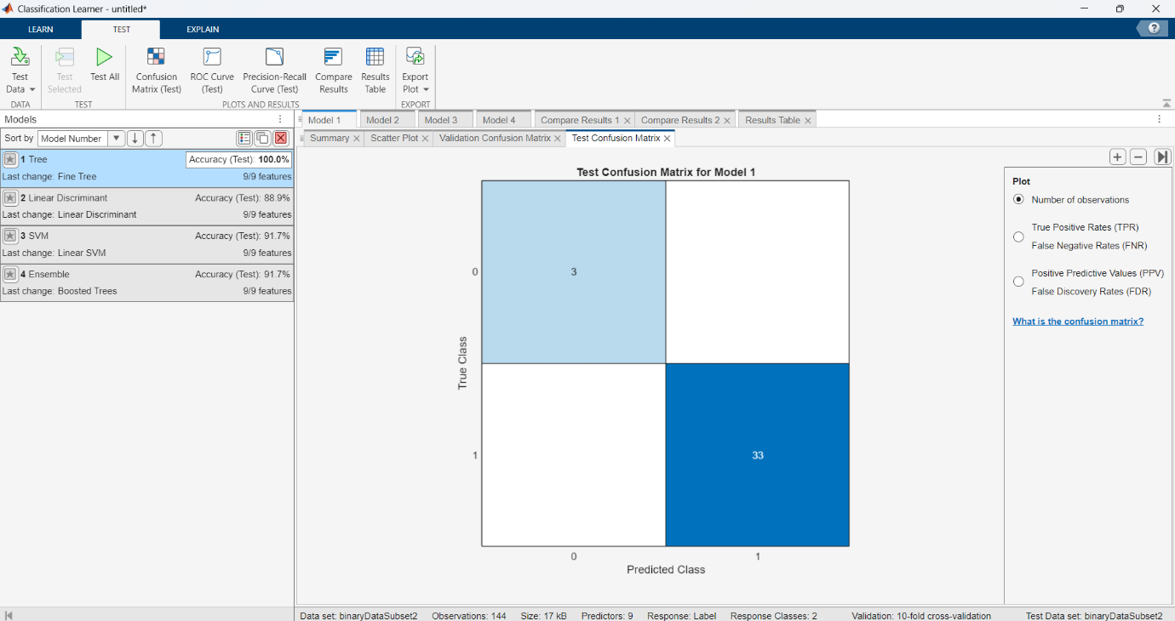  Test Confusion Matrix(Fine Trees)
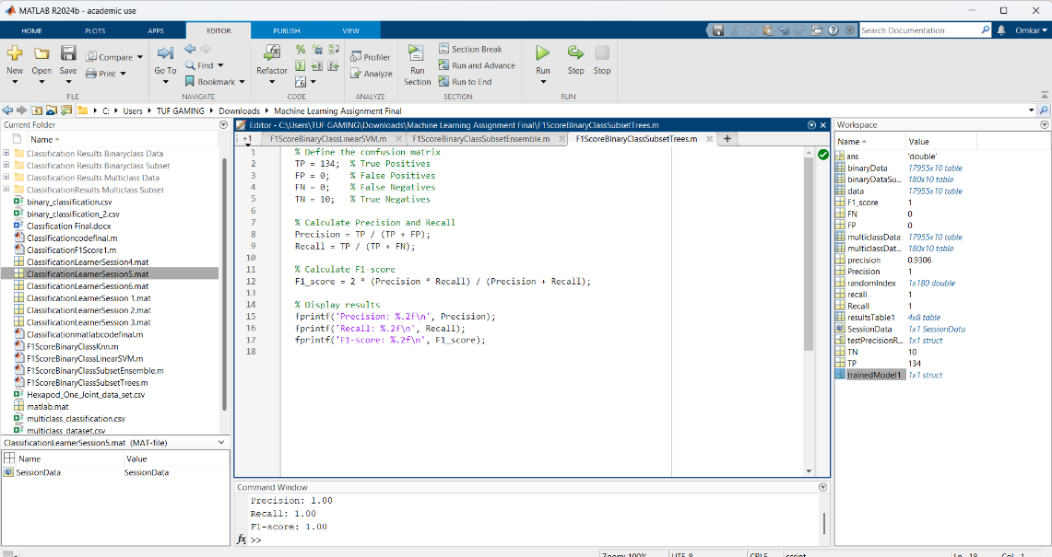  F1 Score(Fine Trees) | 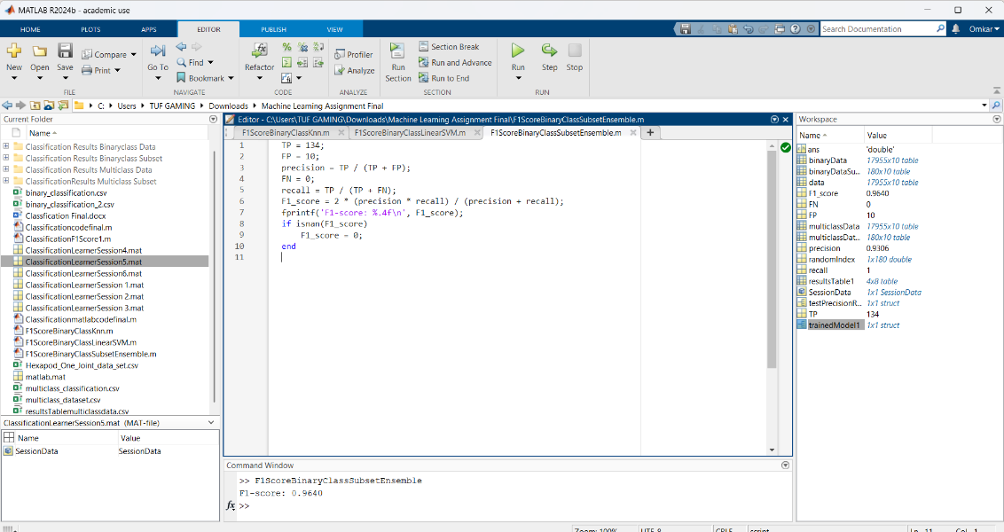  F1 Score(Boosted Trees)
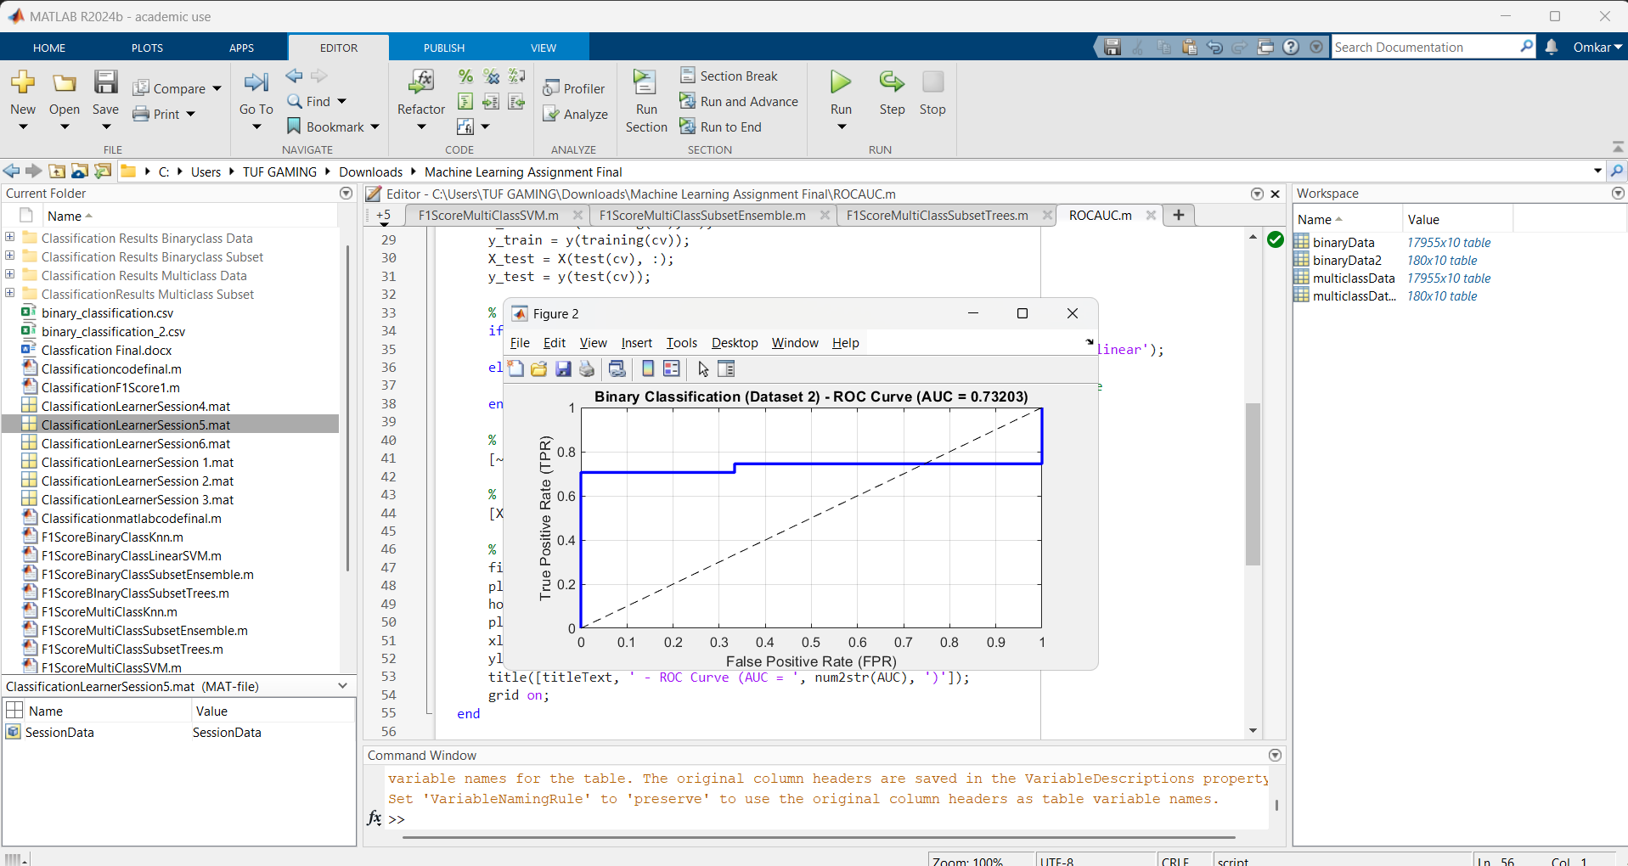
ROC AUC Curve(Binary Subset Data)

Conclusion
From the above results we can conclude that Fine Trees and Boosted Trees(Ensemble) give the best classification in comparison with the other two for binary subset data

3.) Multiclass Data
Multiclass classification in fault detection aims to differentiate between all the different types of faults in hexapod robot joints and below table gives the results: -
Classification Types | Accuracy | F1-Score | AUC-ROC
Fine tree | 98.76 | 0.9956 | 1.000
Linear SVM | 98.07 | 0.998 | 0.9765
Fine KNN | 99.60 | 0.9987 | 0.9259
Boosted Trees | 98.14 | 0.9987 | 0.9526

c) Similarly, we have mentioned the confusion matrix and f1 scores for the two best classification methods used for multiclass dataset
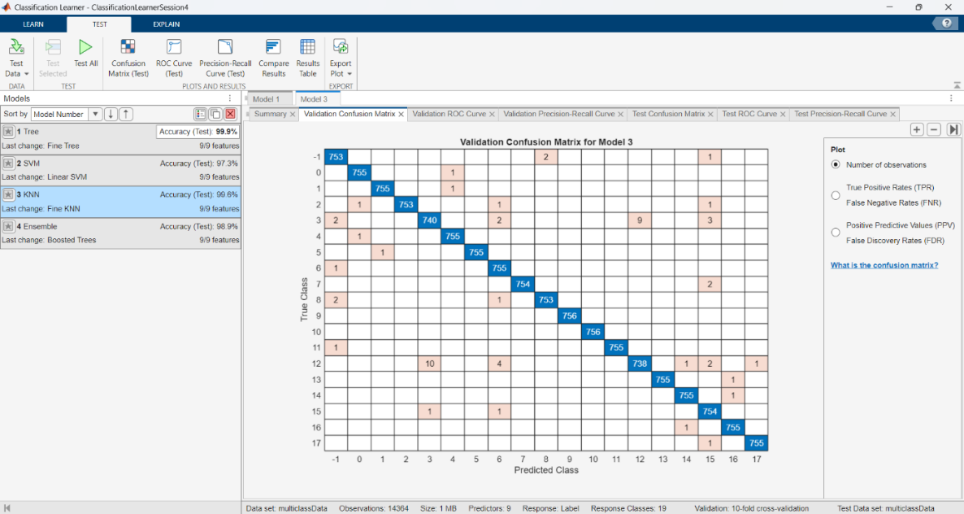  Validation Confusion Matrix(Fine KNN) | 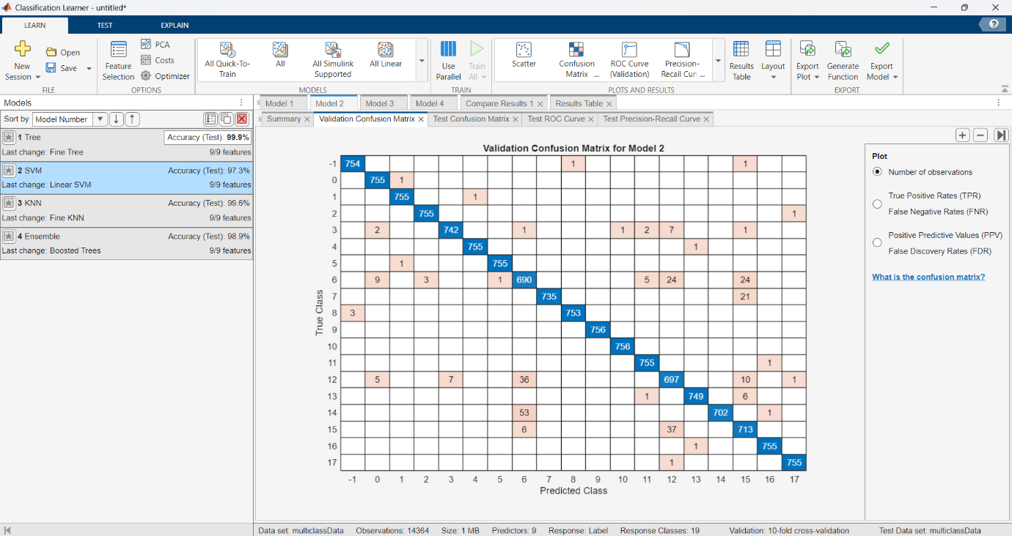  Validation Confusion Matrix(Linear SVM)
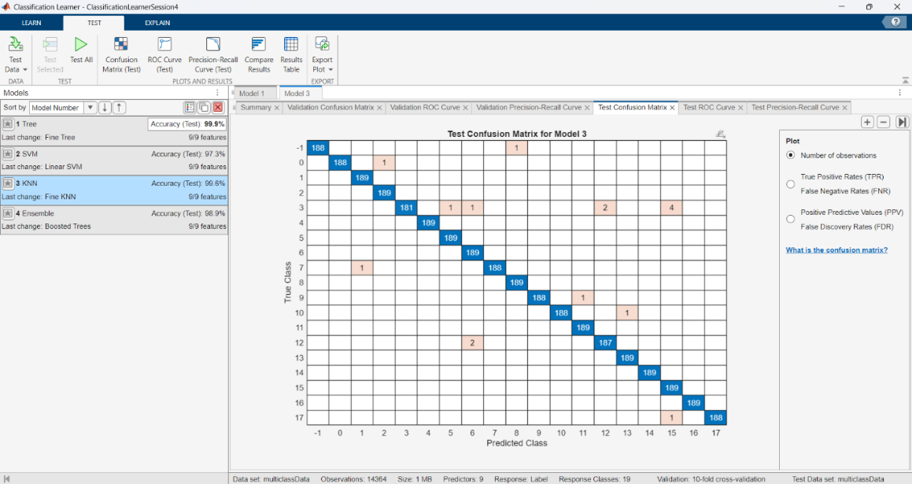  Test Confusion Matrix(Fine KNN) | 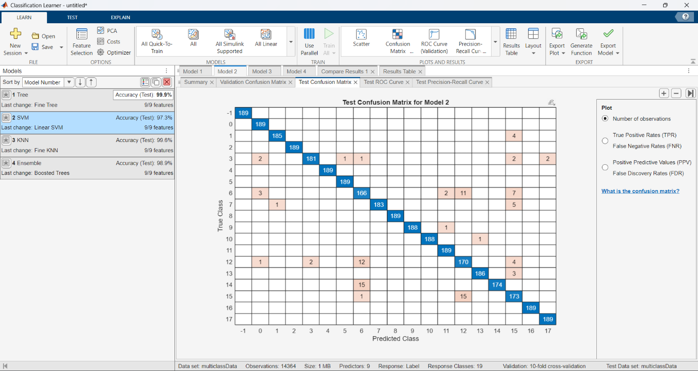  Test Confusion Matrix (Linear SVM)
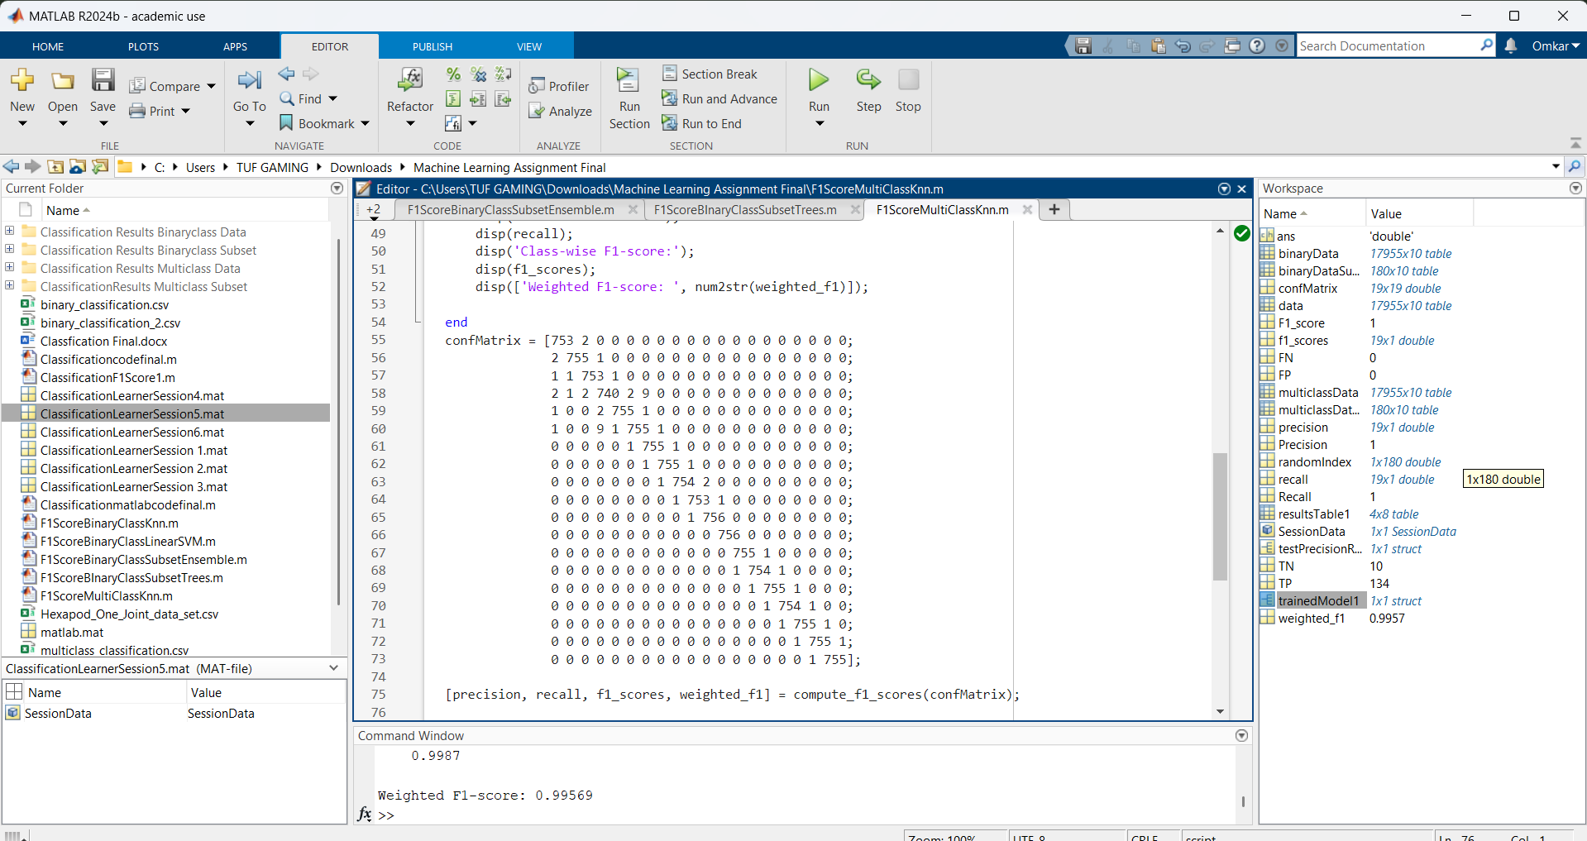  F1 Score(Fine KNN) | 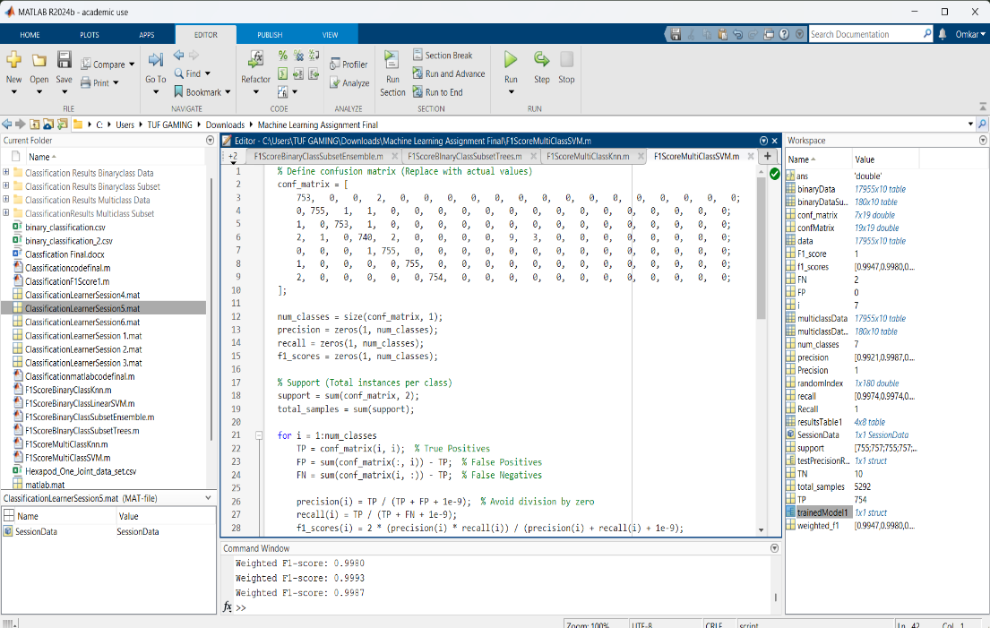  F1 Score(Linear SVM)
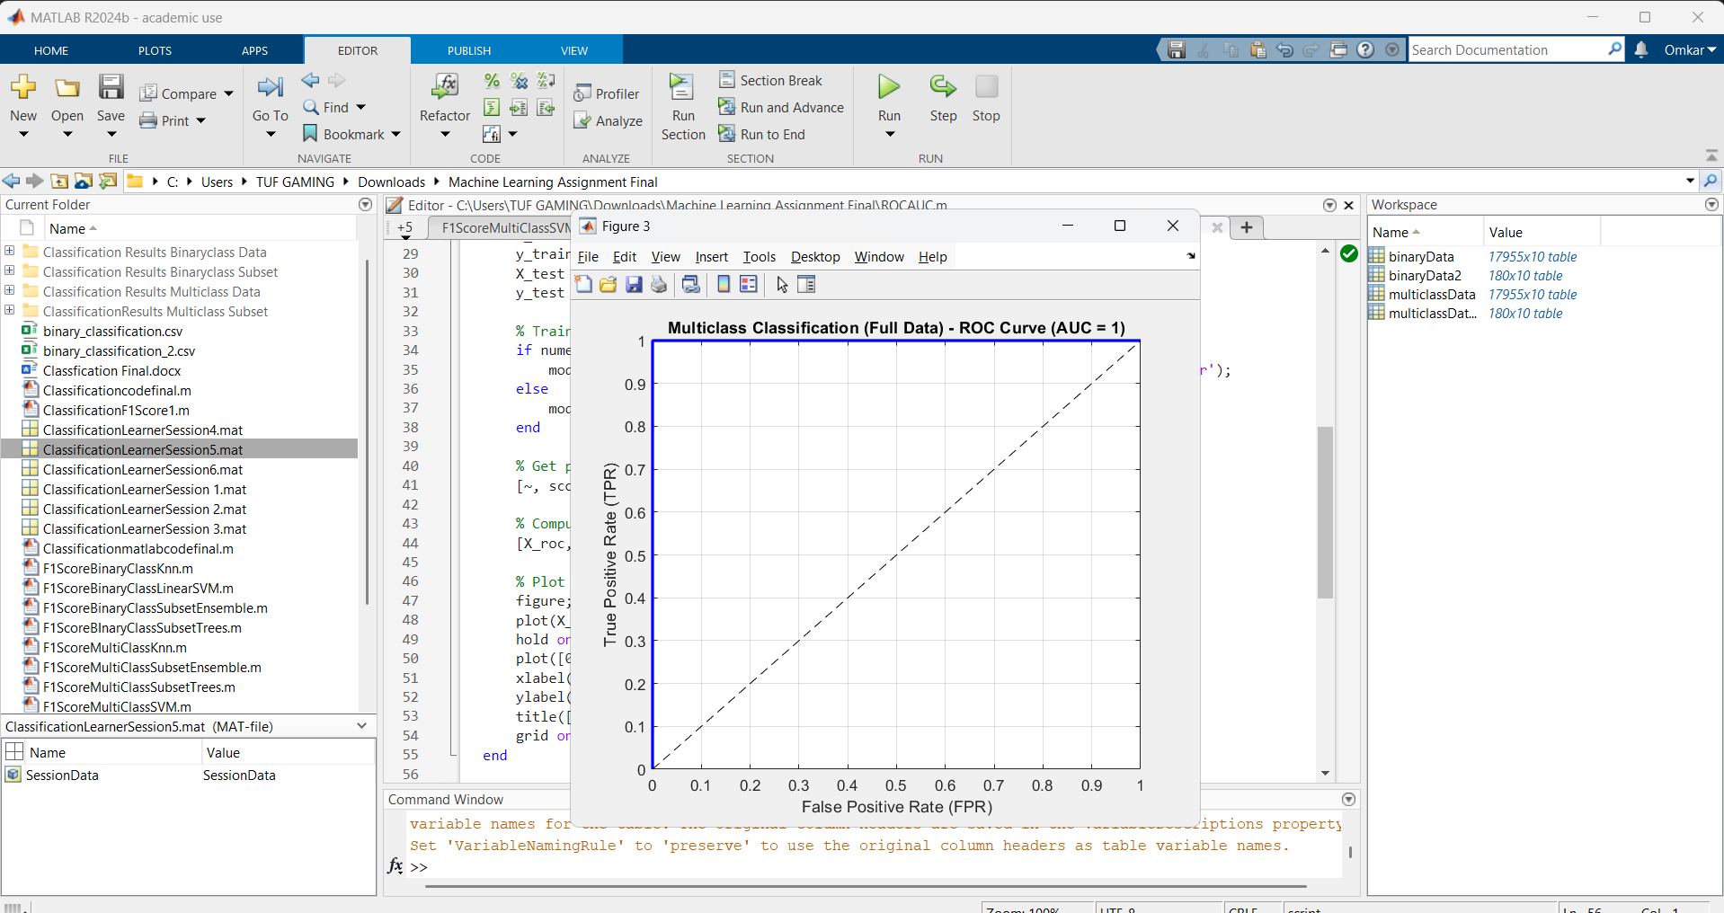
ROC AUC Score(Multiclass Data)

Conclusion
From the above results we can conclude that Fine Tree and Fine KNN give the best possible classification from the other two datasets for multiclass dataset

4.) Multiclass Subset Data
d) Multiclass subset classification in fault detection aims to differentiate between different types of faults in hexapod robot joints and below table gives the results: -
Classification Types | Accuracy | F1-Score | AUC-ROC
Fine tree | 86.11 | 1.000 | 1.000
Linear SVM | 90.97 | 0.9987 | 0.985
Fine KNN | 73.61 | 0.9882 | 0.9660
Boosted Trees | 86.51 | 0.9000 | 0.9436

d) Similarly, we have mentioned the confusion matrix and f1 scores for the two best classification methods used for multiclass subset dataset

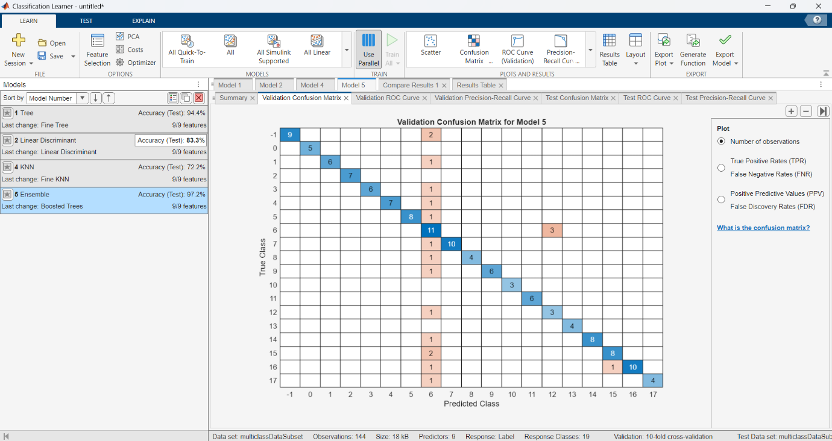  Validation Confusion Matrix(Boosted Trees) | 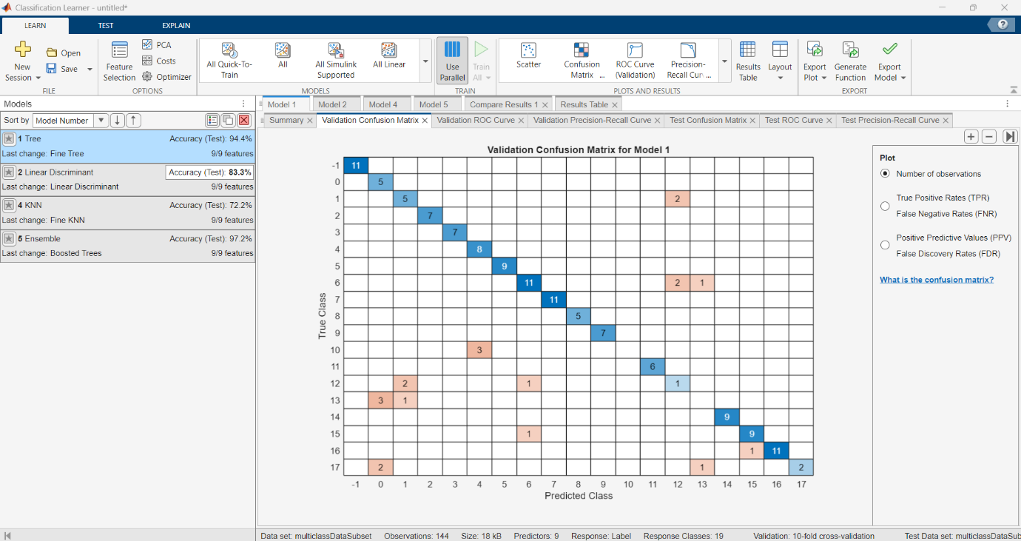  Validation Confusion Matrix(Fine Trees)
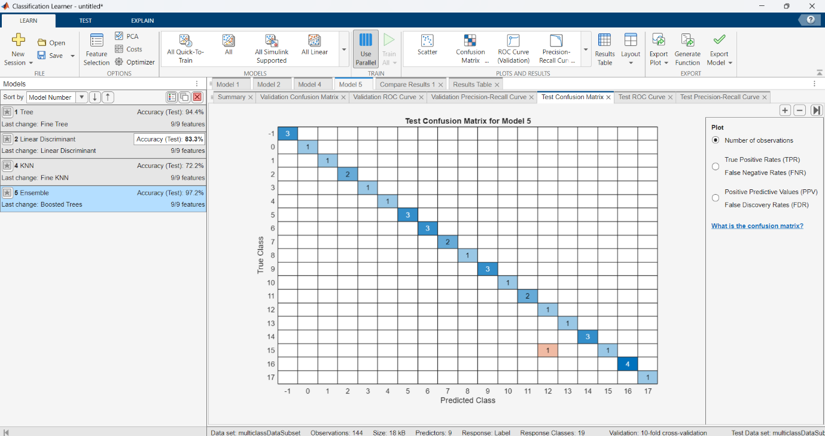  Test Confusion Matrix(Boosted Trees) | 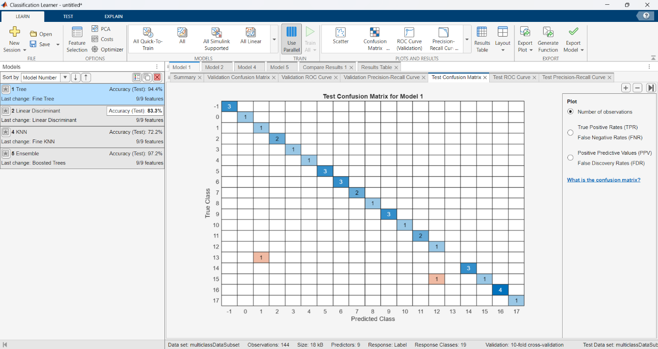Test Confusion Matrix(Fine Trees)
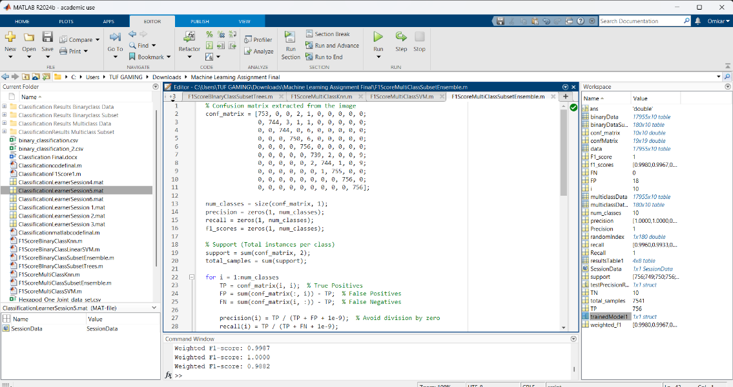  F1 Score(Boosted Trees) | 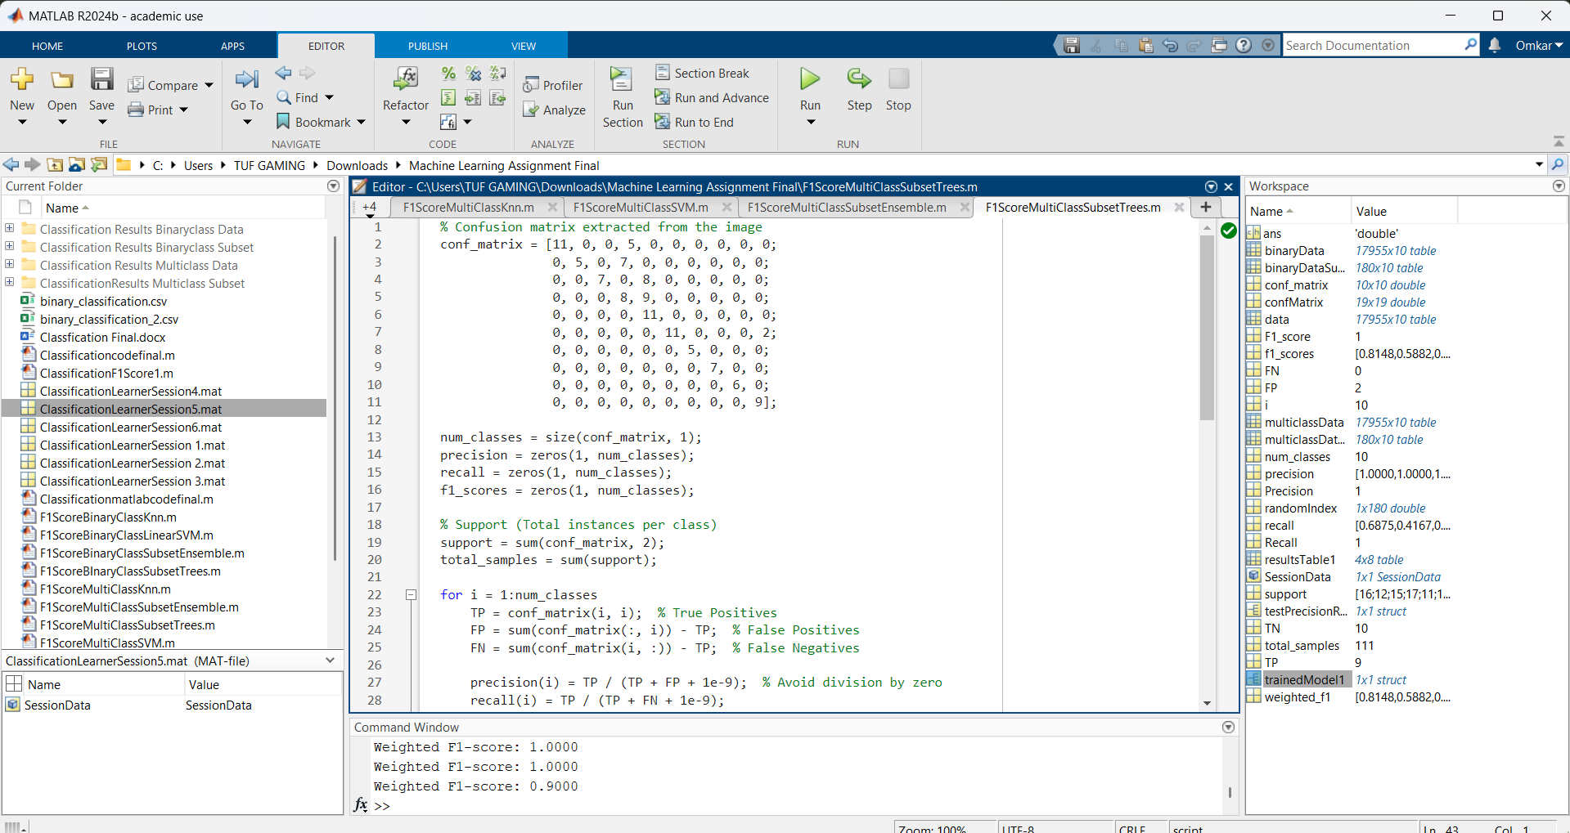  F1 Score(Fine Trees)
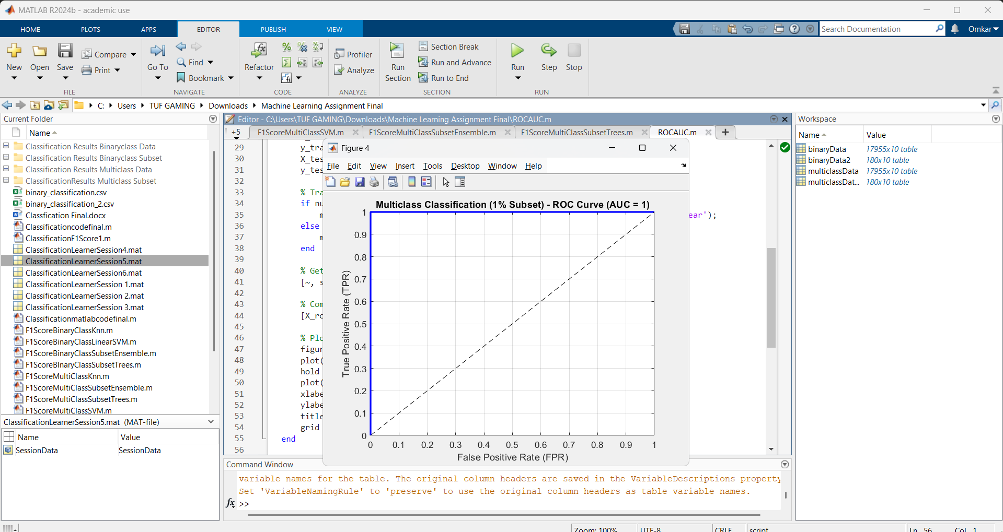
ROC AUC Score(Multiclass Subset Data)

Conclusion
From the above results we can conclude that Linear SVM and Boosted Trees (Ensemble) give the best possible classification apart from the other two methods for multiclass subset data
3)Evaluation (K-Fold Cross Validation)
For K-Fold Cross evaluation we put the value of K=5 and K=10 and compared the results and parameter configurations and these are the results we obtained
1.) Binary Data
Model | Avg. Accuracy | Std Dev | Avg Cost
Fine Trees | 99.98 | 0.01 | 1.00
Linear SVM | 94.74 | 0 | 0
Fine KNN | 99.97 | 0.01 | 2.00
Boosted Trees | 94.74 | 0 | 0

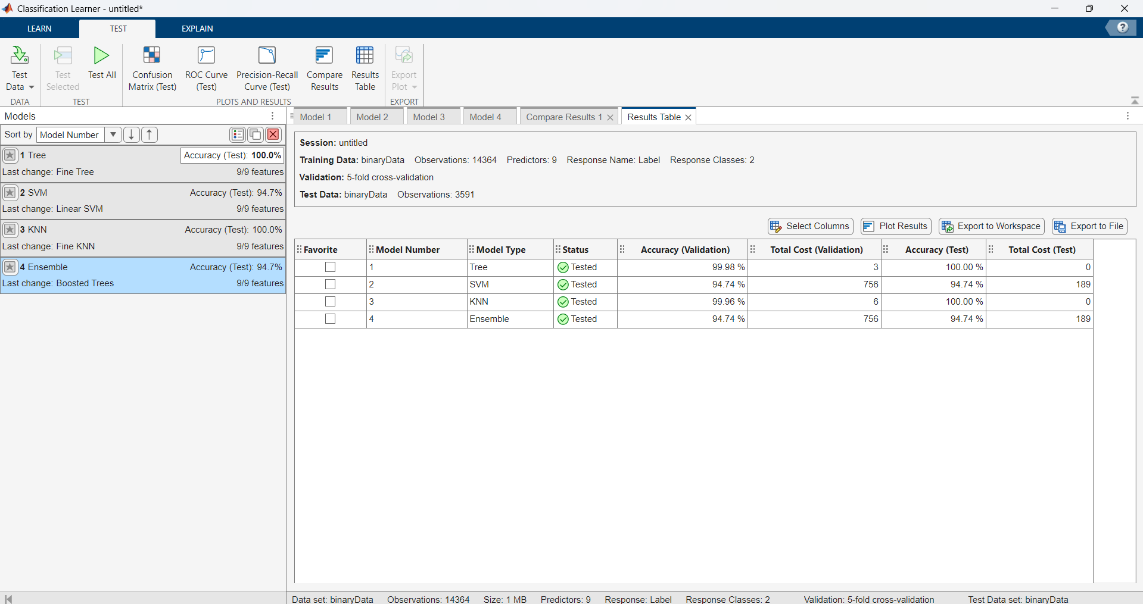
Result Table for Binary Dataset (K = 5)

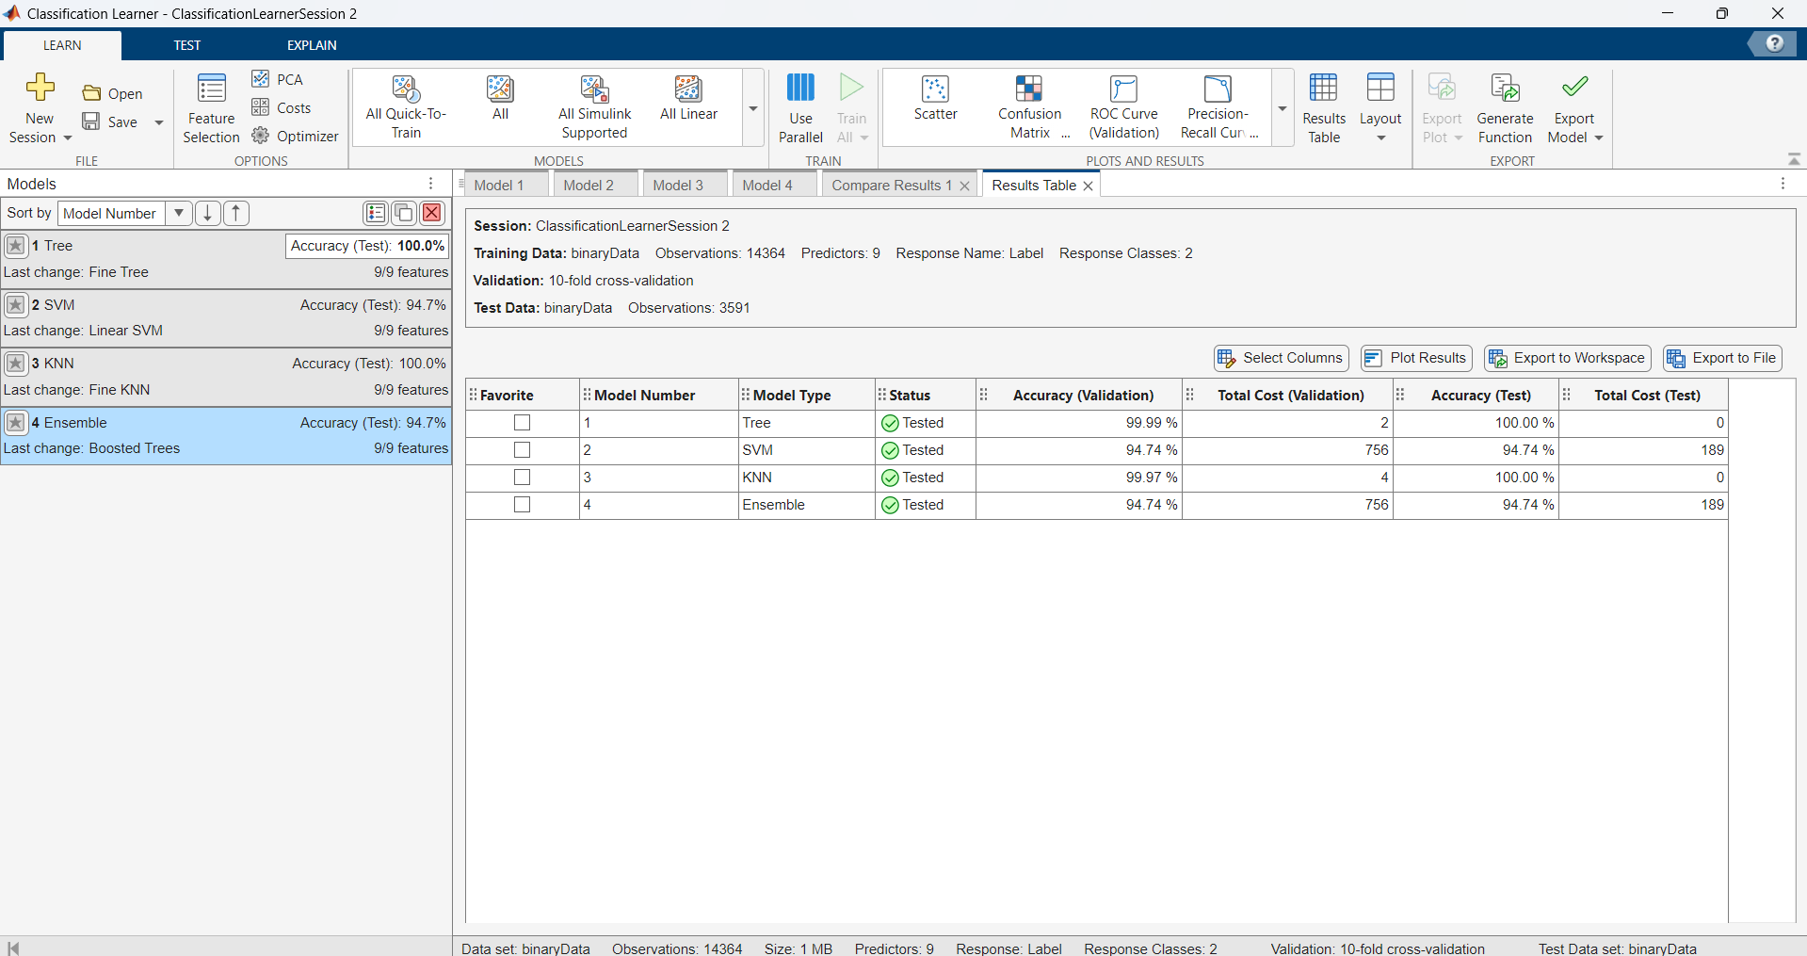
Result Table for Binary Dataset (K = 10)

Conclusion:-
From the above results we conclude that Fine KNN and Fine Trees perform better for K Folds = 5 and K Folds = 10 for the binary dataset
2.) Binary Subset
Model | Avg. Accuracy | Std Dev | Avg Cost
Fine Tree | 99.45 | 00.69 | 0
Linear Discriminant | 92.36 | 01.39 | 14.5
Linear SVM | 95.45 | 04.86 | 9.00
Boosted Trees | 93.02 | 00.69 | 12.5

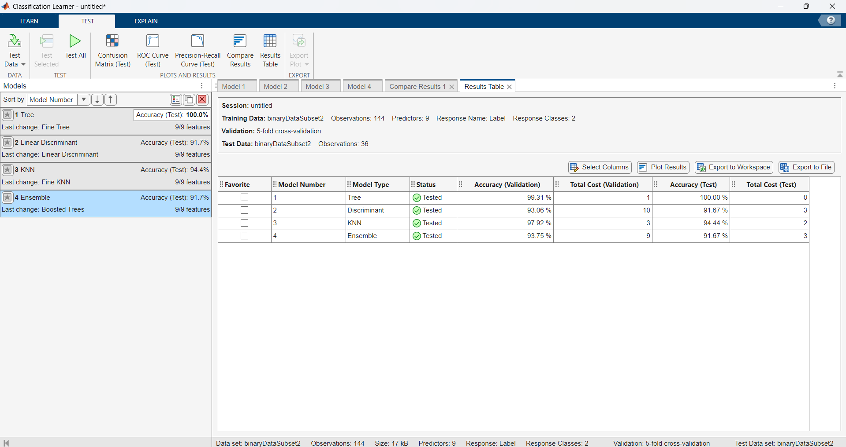
Result Table for Binary Subset (K = 5)

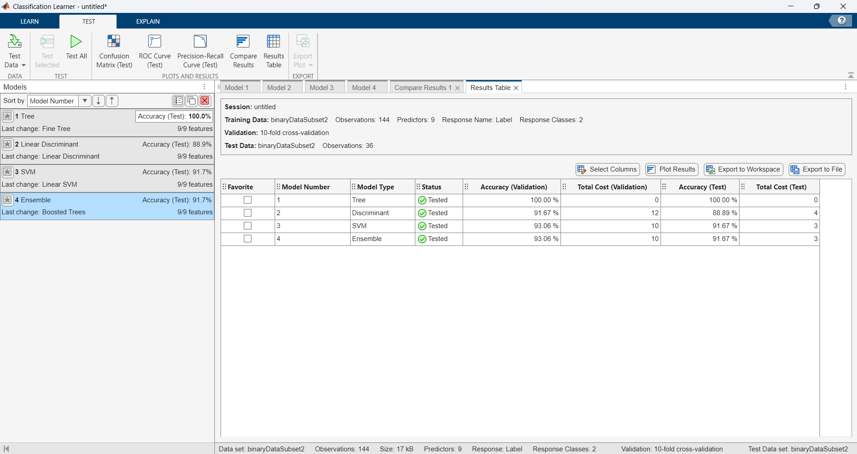
Result Table for Binary Subset (K = 10)

From the above results we conclude that Linear SVM and Fine Trees perform better for K Folds = 5 and K Folds = 10 for the binary subset

3.) Multiclass Dataset
Model | Avg. Accuracy | Std Dev | Avg Cost
Fine Tree | 99.79 | 00.20 | 7.5
Linear SVM | 97.52 | 00.61 | 85
Fine KNN | 99.63 | 00.17 | 13
Boosted Trees | 98.49 | 00.67 | 53

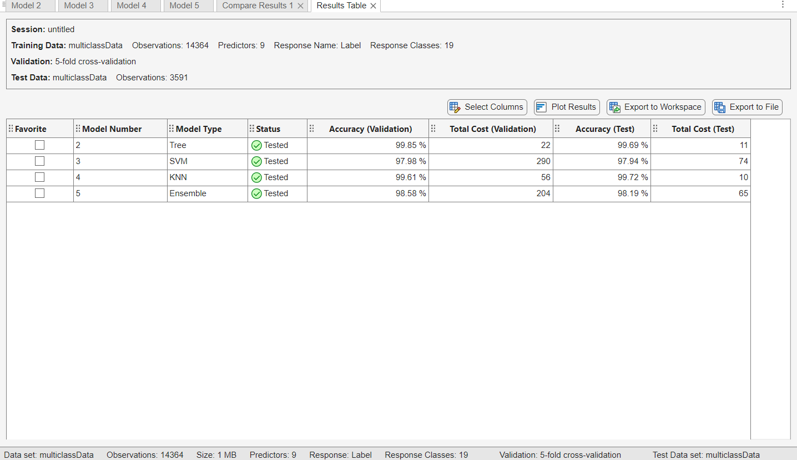
Result Table for Multiclass Dataset(K = 5)

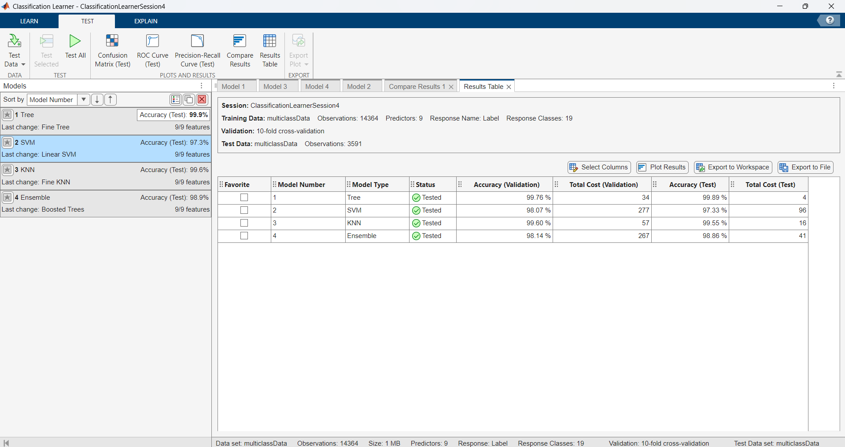
Result Table for Multiclass Dataset(K=10)

Conclusion: -
From the above results we conclude that Fine Trees and Fine KNN perform better for K Folds = 5 and K Folds = 10 for the multiclass dataset
4.) Multiclass Subset
Model | Avg. Accuracy | Std Dev | Avg Cost
Fine Tree | 99.79 | 00.20 | 7.5
Linear SVM | 97.52 | 00.61 | 85
Fine KNN | 99.63 | 00.17 | 13
Boosted Trees | 98.49 | 00.67 | 53

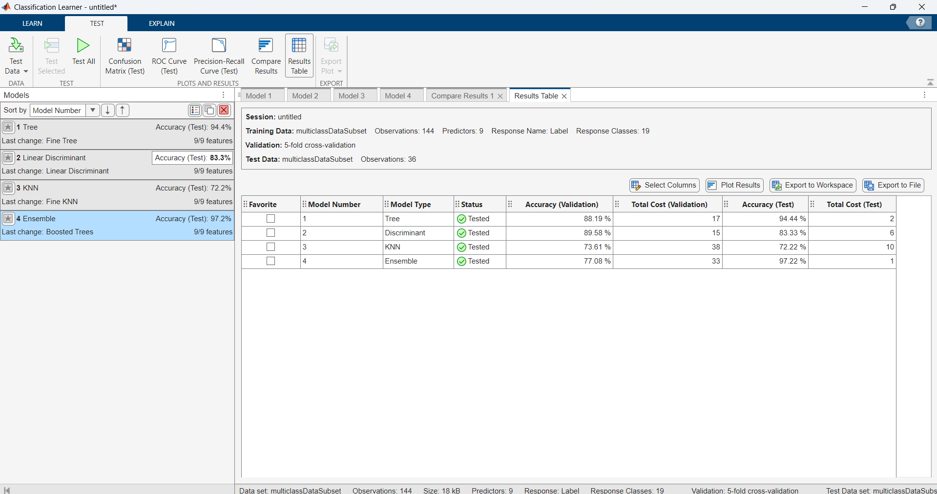
Result table for multiclass subset(K=5)

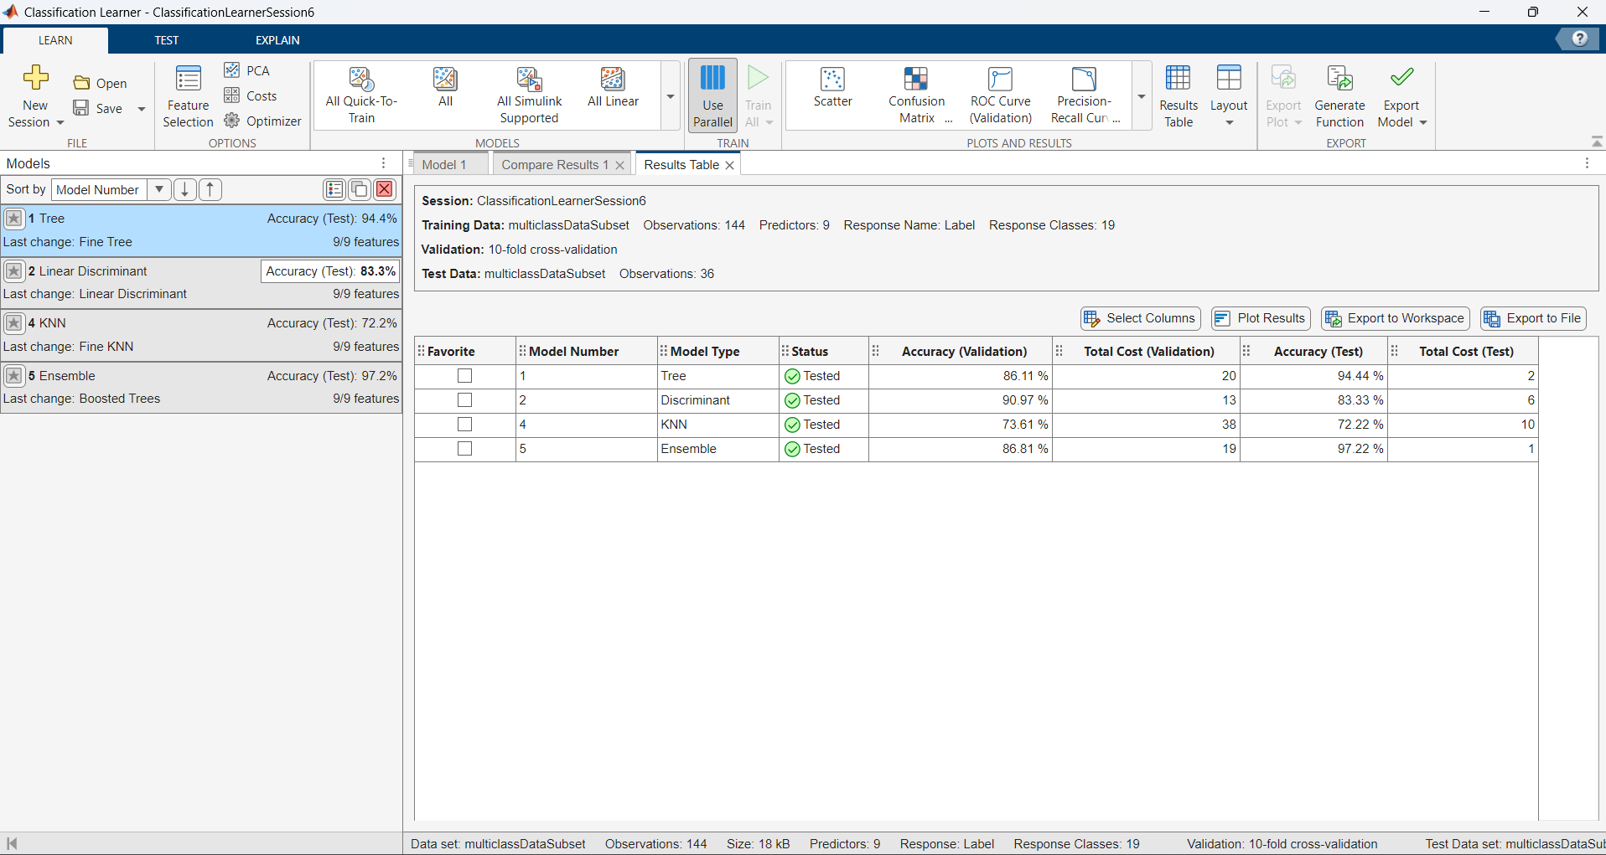
Result Table for multiclass subset(K=10)

Conclusion
From the above results we conclude that Linear Discriminant (LDA) and Boosted Trees (Ensemble) perform better for K Folds = 5 and K Folds = 10 for the multiclass subset

PART IV – Classification using Neural Networks
While working with datasets containing multiple faults in the joints of a hexapod robot, we discovered that patternNet is an ideal choice for our coursework on fault classification. It effectively integrates with feature extraction techniques, offering multiple hidden layers that support hierarchical feature representation. Additionally, it’s flexible network topology allows for easy adjustments to the number of neurons and layers. The patternnet function is specifically designed for classification tasks, with the objective of assigning input patterns to predefined categories.
The neural network used for pattern recognition is trained using the patternnet function.
“patternnet(hiddenLayerSize)”
patternnet is specifically designed for pattern recognition and classification problems. This function provides an efficient framework for training feedforward neural networks using backpropagation.

- Binary Classification (Fault/No Fault):
In our dataset, we need to determine whether a joint has a fault or not. The patternnet function effectively learns patterns in the data and assigns them to one of the two categories.
- Multi-Class Classification (Different Fault Types):
As our dataset contains multiple fault categories, patternnet can be adapted to handle multi-class classification by using one-hot encoding for the target labels.
Normalising data
Neural networks perform better when input data is normalized.
Adding X = normalize(X); to the MATLAB code improves the performance of the neural network by ensuring that all features are on a similar scale.
Without normalisation, the data may have features with vastly different magnitudes i.e. features with large values dominate learning. Also, the neural network may struggle to adjust weights efficiently and it might take longer time to reach an optimal state.
After Adding Normalization, each feature is scaled so that it has:
- A mean of 0
- A standard deviation of 1
Now, all input features are on the same scale, preventing larger features from dominating.
This allows the network to learn efficiently and provides optimal output.

Binary Data
Below, we experimented with binary data with patternnet and trainNetwork, and after considering imbalanced data, we trained the patternnet network on an equal number of fault and no-fault samples of binary data to get better results.
By experimenting with different training splits and hyperparameters and evaluating the classification approaches using metrics such as ROC AUC and a confusion matrix, we get the following results,
- Training with patternnet
Hyperparameters used are as follows,
- Epochs
It helps to determine the no. of times the model learns from the training data.
- Learning rate
It controls the step size at which the model updates its weights during training
- Neural Layers
The no. of hidden layers and neurons for each layer determines the model’s ability to learn complex patterns

We determine the AUC (Area under the curve) Value represents ability of the model to distinguish between classes.
AUC = 1.0 → Perfect model (ideal classifier).
AUC = 0.5 → Random guessing (no predictive power).
AUC < 0.5 → Worse than random (model is making incorrect predictions)

We trained with different training splits 70/30 and 80/20 using the patternnet function.

 | Training Splits in Percentage 70/30%
Hyperparameter | No. of layers | Epochs |  | Learning rate |  | AUC Value
 | 1 | 50  100  200  300 |  | 0.1  0.01  0.001  0.0001 |  | 0.866  0.9864  0.853  0.992
 | 2 | 50  100  200  300 |  | 0.1  0.01  0.001  0.0001 |  | 0.9241  0.9917  0.9987  0.99935
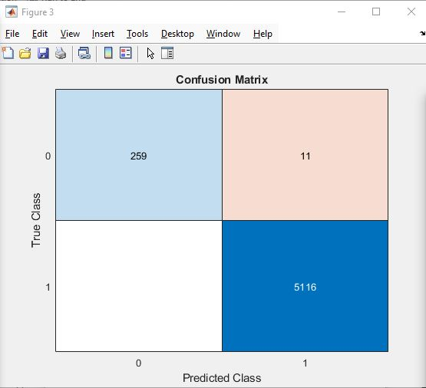 |  |  | 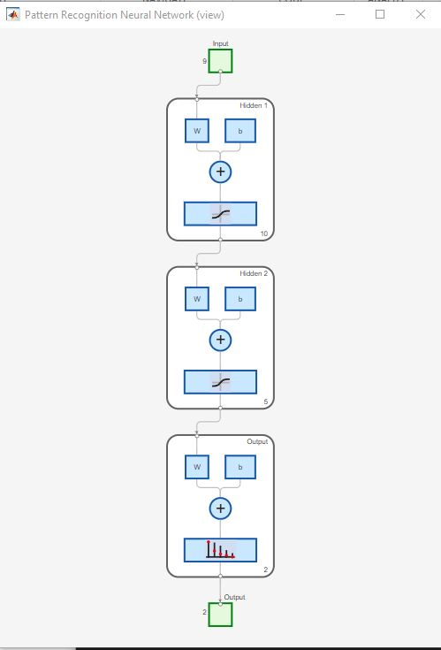 |  | 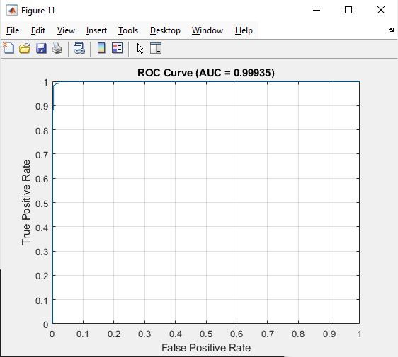
 | Training Splits in Percentage 80/20%
Hyperparameter | No. of layers | Epochs |  | Learning rate |  | AUC Value
 | 1 | 50  100  200  300 |  | 0.1  0.01  0.001  0.0001 |  | 0.9418  0.9758  0.8694  0.99682
 | 2 | 50  100  200  300 |  | 0.1  0.01  0.001  0.0001 |  | 0.9624  0.9982  0.99954  0.9872
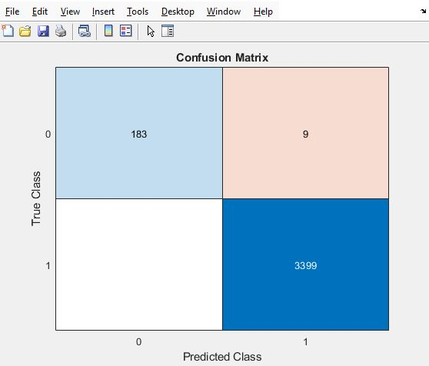 |  |  |  |  | 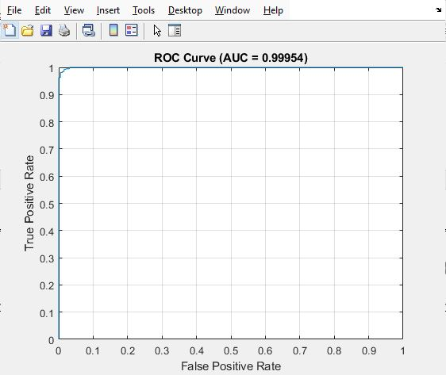

Analysis of Underfitting and Overfitting in our Results

Potential underfitting in your results:
- At 50 epochs, 1-layer models:
  - 70/30 split: AUC = 0.866 (low)
  - 80/20 split: AUC = 0.9418 (better but still lower than deeper models)
- At 0.1 learning rate across all epochs and splits:
  - AUC values are consistently lower compared to smaller learning rates.
  - Example:
    - 70/30 split, 1-layer, 50 epochs, 0.1 LR → AUC = 0.866
    - 80/20 split, 1-layer, 50 epochs, 0.1 LR → AUC = 0.9418
  - The high learning rate may have prevented convergence.
Conclusion on underfitting:
- 1-layer models are underfitting at lower epochs.
- High learning rates (0.1) lead to underfitting as they prevent proper weight updates.

2. Signs of Overfitting
Potential overfitting in our results:
- For 2-layer models with 300 epochs, 0.0001 LR:
  - 70/30 split: AUC = 0.99935 (very close to 1.0)
  - 80/20 split: AUC = 0.9872 (slightly lower)
  - The high AUC suggests the model may have memorized training data.
- Higher AUC with a larger training split (80/20):
  - 80/20 split should generalize better due to more training data, yet the AUC drops slightly (0.99935 → 0.9872) for deep models.
  - This drop suggests that the 70/30 model is overfitting because it performs worse when tested on slightly more unseen data.
Conclusion on overfitting:
- 2-layer models with 300 epochs and 0.0001 LR might be overfitting (AUC ~0.999).
- Slight AUC drop from 70/30 to 80/20 split suggests possible overfitting.
Underfitting: Found in shallow (1-layer) models at fewer epochs (50) and high learning rates (0.1).
Overfitting: Likely in deep (2-layer) models with many epochs (300) and small learning rates (0.0001), as AUC is too high (~0.999).
- Training with trainNetwork
trainNetwork is a MATLAB function used to train deep learning models, including neural networks, with various types of layer architectures. It is a flexible function that works with different types of models, including feedforward neural networks, convolutional neural networks (CNNs), recurrent neural networks (RNNs), and more.
- trainNetwork allows us to define custom structures. We can specify various layers, activation functions, batch normalization, and dropout layers.
- The network cooperates with Adam, RMSprop, SGDM (Stochastic Gradient Descent with Momentum), and others to aid in convergence.
- It can train models in mini batches, reducing memory usage for large datasets.

Binary data has been trained with a custom network to check for better result, but the AUC value gives poor result when trained with different parameters.
Layers used in the network
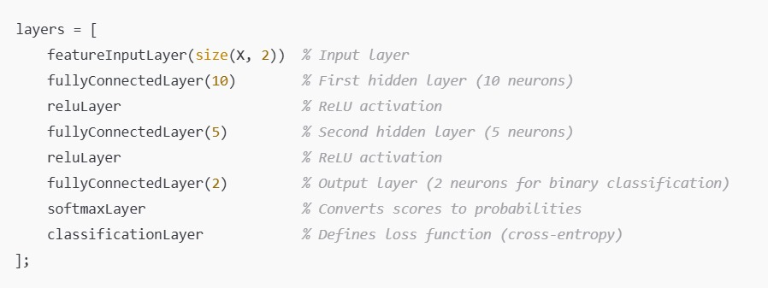confusion matrix and AUC value obtained from training above network
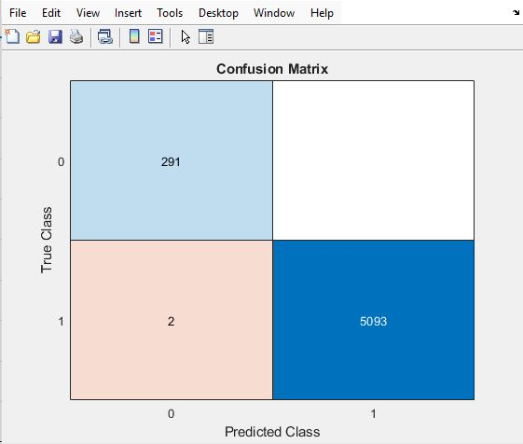 | 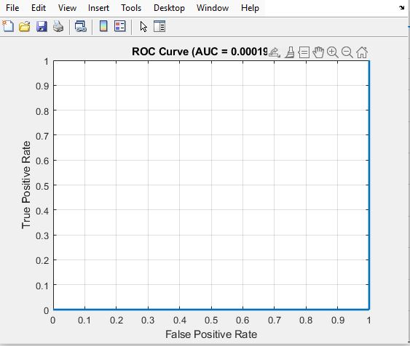

- Training with patternnet using equal sampling of fault and no-fault binary data

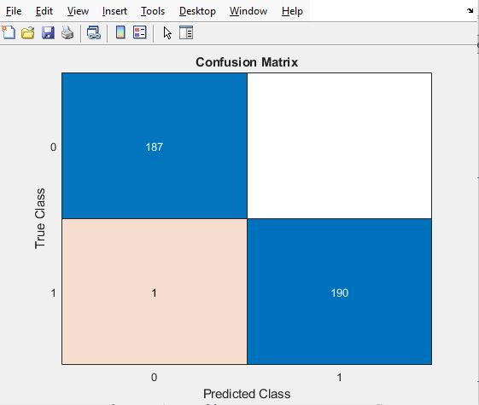 | 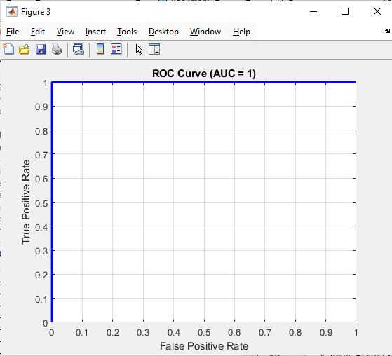

For a 2 layered network with 10 and 5 neurons and for an epoch and learning rate of 300 and 0.0001 respectively gives a reliable confusion matrix and AUC value 1.
1% Binary Data
A random sample of 1% of binary data was trained using the patternnet network, we have trained with different training splits using the function of 70/30 and 80/20

 | Training Splits in Percentage 70/30%
Hyperparameter | No. of layers | Epochs |  | Learning rate | AUC Value
 | 1 | 50  100  200  300 |  | 0.1  0.01  0.001  0.0001 | 0.9047  0.9821  0.9788  0.9941
 | 2 | 50  100  200  300 |  | 0.1  0.01  0.001  0.0001 | 0.9258  0.8086  0.9997  0.9512
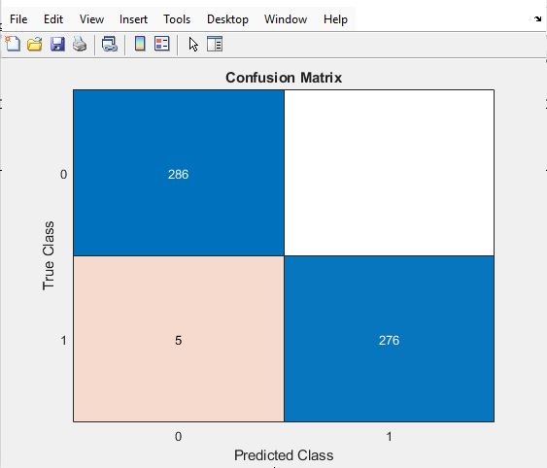 |  |  | 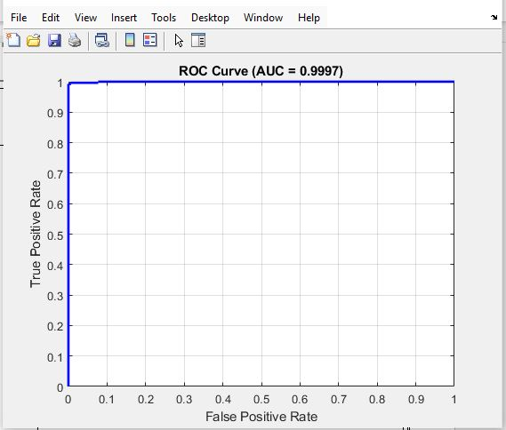
 | Training Splits in Percentage 80/20%
Hyperparameter | No. of layers | Epochs |  | Learning rate | AUC Value
 | 1 | 50  100  200  300 |  | 0.1  0.01  0.001  0.0001 | 0.8381  0.9752  0.8833  0.9950
 | 2 | 50  100  200  300 |  | 0.1  0.01  0.001  0.0001 | 0.8185  0.9997  1  0.9989
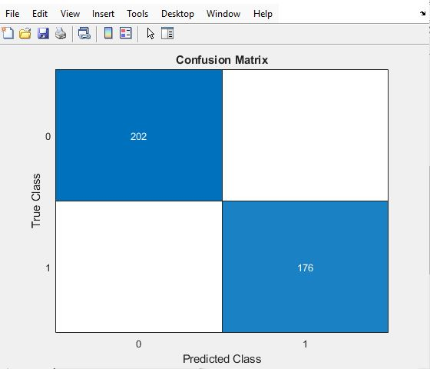 |  |  |  | 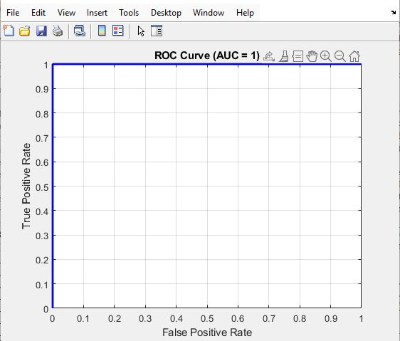

Analysis of Underfitting and Overfitting in Your Results
1. Signs of Underfitting
Potential underfitting in our results:
- 1-layer, 50 epochs, 0.1 learning rate (both splits):
  - 70/30 split: AUC = 0.9047
  - 80/20 split: AUC = 0.8381 (lower than 70/30)
- 2-layer, 50 epochs, 0.1 learning rate:
  - 70/30 split: AUC = 0.9258
  - 80/20 split: AUC = 0.8185 (lower than 1-layer model)
  - Suggests the model is struggling at 50 epochs, possibly not trained enough.
Conclusion on underfitting:
- Underfitting is present at 50 epochs, especially at a 0.1 learning rate.
- Increasing epochs and lowering learning rate improves performance.

2. Signs of Overfitting
Potential overfitting in our results:
- 2-layer, 200 epochs, 0.001 learning rate:
  - 70/30 split: AUC = 0.9997
  - 80/20 split: AUC = 1.0 (perfect score, which is unrealistic)
  - AUC too high suggests overfitting to the training data.
- 2-layer, 300 epochs, 0.0001 learning rate:
  - 70/30 split: AUC = 0.9512
  - 80/20 split: AUC = 0.9989
  - The model is likely overfitting with deep layers and small learning rates.
Conclusion on overfitting:
- Severe overfitting occurs at 2 layers, 200–300 epochs, and 0.001–0.0001 learning rate.
- The 80/20 split results confirm overfitting

Underfitting at 50 epochs and 0.1 learning rate (not enough training).
Overfitting at 2 layers, 200+ epochs, and small learning rates (0.001 & 0.0001) (memorizing training data).

Multiclass Dataset
Below we experimented multiclass data with patternnet under different parameter to obtain ROC curve and confusion matrix.

 | Training Splits in Percentage 70/30%
Hyperparameter | No. of layers | Epochs |  | Learning rate | AUC Value
 | 1 | 50  100  200  300 |  | 0.1  0.01  0.001  0.0001 | 0.9879  0.99307  0.99685  1
 | 2 | 50  100  200  300 |  | 0.1  0.01  0.001  0.0001 | 0.9336  0.9457  0.9994  0.98901
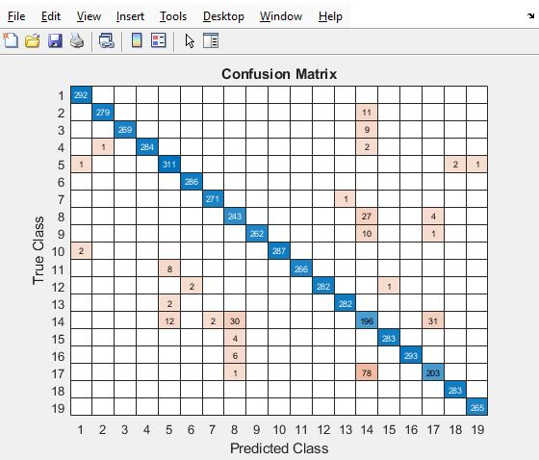 |  |  |  | 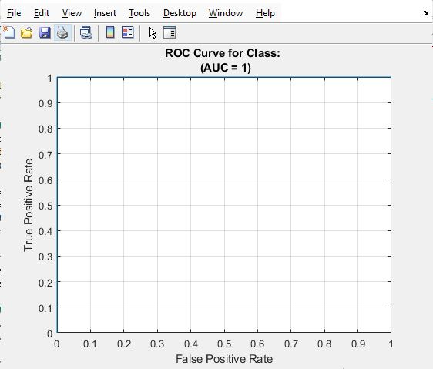
 | Training Splits in Percentage 80/20%
Hyperparameter | No. of layers | Epochs |  | Learning rate | AUC Value
 | 1 | 50  100  200  300 |  | 0.1  0.01  0.001  0.0001 | 0.9522  0.9944  0.9987  1
 | 2 | 50  100  200  300 |  | 0.1  0.01  0.001  0.0001 | 0.8570  0.93182  0.98572  0.9618
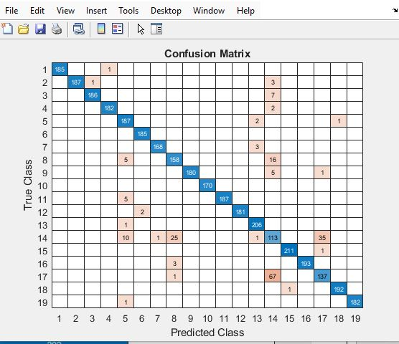 |  |  | 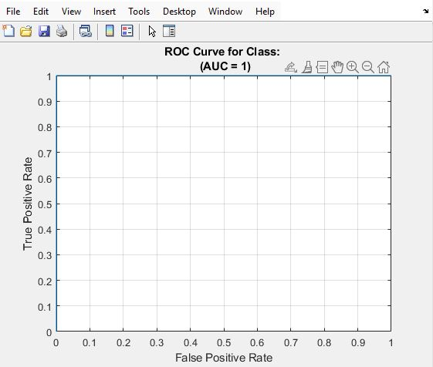

Analysis of Underfitting and Overfitting in Your Results
1. Underfitting Analysis
No major underfitting detected:
- The lowest AUC value observed is 0.8570 (80/20 split, 2-layer, 50 epochs, 0.1 learning rate).
- All other values are above 0.9, which indicates the model is learning well.
- Increasing epochs and reducing the learning rate improves AUC values, showing that the model is benefiting from more training.
Conclusion: No clear underfitting issue. The model performs well even at lower epochs and higher learning rates.

2. Overfitting Analysis
Possible overfitting signs:
- 1-layer, 300 epochs, 0.0001 learning rate:
  - 70/30 split: AUC = 1.0
  - 80/20 split: AUC = 1.0
- 2-layer, 200 epochs, 0.001 learning rate:
  - 70/30 split: AUC = 0.9994
  - 80/20 split: AUC = 0.98572
  - Very high AUC, but a slight drop in the 80/20 split, indicating mild overfitting.
Conclusion: Overfitting is likely present in deeper models with 200+ epochs and very small learning rates (0.001 or 0.0001). The model may be memorizing training data rather than generalizing.
No underfitting (even the lowest AUC is reasonable).
Overfitting is likely in 2-layer, high-epoch, low learning rate settings (e.g., 300 epochs, 0.0001 learning rate).

1% Multiclass Dataset
A random sample of 1% of multiclass data was trained using the patternnet network, We trained with different training splits 70/30 and 80/20 using different parameters.
 | Training Splits in Percentage 70/30%
Hyperparameter | No. of layers | Epochs |  | Learning rate | AUC Value
 | 1 | 50  100  200  300 |  | 0.1  0.01  0.001  0.0001 | 0.98693  1  0.9869  1
 | 2 | 50  100  200  300 |  | 0.1  0.01  0.001  0.0001 | 1  1  1  0.9934
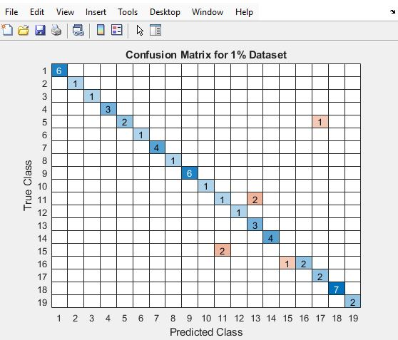 |  |  |  | 
 | Training Splits in Percentage 80/20%
Hyperparameter | No. of layers | Epochs |  | Learning rate | AUC Value
 | 1 | 50  100  200  300 |  | 0.1  0.01  0.001  0.0001 | 1  0.9411  1  1
 | 2 | 50  100  200  300 |  | 0.1  0.01  0.001  0.0001 | 1  1  0.9090  1
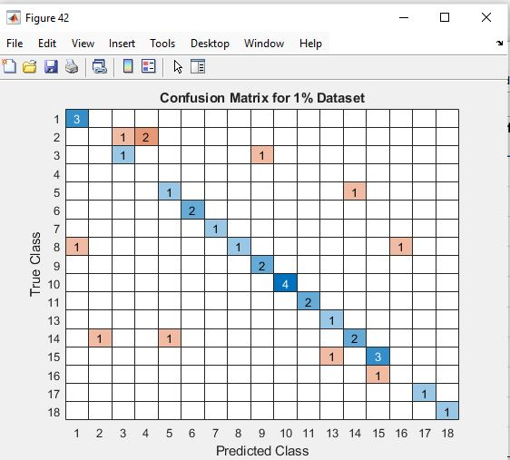 |  |  | 

Analysis of Overfitting and Underfitting
Overfitting Analysis
1. AUC = 1 Across Multiple Settings
In both training splits, multiple configurations (especially with 2 layers and higher epochs) achieve AUC = 1.
This suggests that the network memorized the training data, which is a strong indication of overfitting.
2. Effect of Learning Rate and Epochs
In the first split (70/30%), with 2 layers and a learning rate of 0.0001, the model achieves AUC = 1 at 50, 100, and 300 epochs.
Conclusion on Overfitting
• Since multiple configurations reach AUC = 1, it's likely that the network has low bias but high variance, meaning it has memorized training data instead of learning generalizable patterns.

Underfitting Analysis
Indicators of Underfitting in our Results
1. Lower AUC at Specific Epochs
For the 1-layer model at 100 epochs with 0.01 learning rate, AUC = 0.9411.
For the 2-layer model at 200 epochs with 0.001 LR, AUC = 0.9090.
These values indicate that the model has not yet fully learned the patterns, meaning it may require more training epochs or a slightly larger network.
2. Performance Variation Based on Learning Rate
At 200 epochs with 0.001 LR, AUC is 0.9090, while at 300 epochs, AUC = 1.
This suggests that the model needed more training to learn the patterns.
3. Comparison of 1-Layer vs. 2-Layer Networks
- The 1-layer network performs slightly worse in some cases (e.g., 0.9411 AUC), meaning it may lack the complexity to fully learn the dataset.
- However, the 2-layer network improves AUC after more epochs, showing that more training was needed to improve performance.
Conclusion on Underfitting
- When AUC is below 1 (e.g., 0.9090, 0.9411), it suggests the model hasn't fully captured the data's complexity.

References
- Jain, A.K. (2010) 'Data clustering: 50 years beyond K-means', Pattern Recognition Letters, 31(8), pp. 651–666. Available at: https://www.sciencedirect.com/science/article/abs/pii/S0167865509002323.
[Accessed 22 March 2025]
- Ester, M., Kriegel, H.P., Sander, J. and Xu, X. (1996) 'A Density-Based Algorithm for Discovering Clusters in Large Spatial Databases with Noise', Proceedings of the 2nd International Conference on Knowledge Discovery and Data Mining (KDD), pp. 226–231. Available at: https://file.biolab.si/papers/1996-DBSCAN-KDD.pdf.[Accessed 20 March 2025]
- Chawla, N.V., Bowyer, K.W., Hall, L.O. and Kegelmeyer, W.P. (2002) 'SMOTE: Synthetic Minority Over-sampling Technique', Journal of Artificial Intelligence Research, 16, pp. 321–357. Available at: https://arxiv.org/pdf/1106.1813.[Accessed 14 March 2025]
- MathWorks (n.d.) patternnet. Available at: https://www.mathworks.com/help/deeplearning/ref/patternnet.html [Accessed 10 March 2025].
- Haykin, S. (2009) Neural Networks and Learning Machines. 3rd edn. Upper Saddle River, NJ: Pearson. Available at: https://dai.fmph.uniba.sk/courses/NN/haykin.neural-networks.3ed.2009.pdf.[Accessed 15 March 2025]
- MathWorks (n.d.) Deep Learning Toolbox User's Guide. Available at: https://www.mathworks.com/help/deeplearning/index.html [Accessed 20 March 2025].
- Bishop, C.M. (2006) Pattern Recognition and Machine Learning. New York: Springer. Available at: https://www.cs.man.ac.uk/~fumie/tmp/bishop.pdf.[Accessed 10 March 2025]
- MathWorks (n.d.) Classification. Available at: https://www.mathworks.com/help/stats/classification.html [Accessed 14 March 2025]
- Feldesman, M. R. (2002). Classification trees as an alternative to linear discriminant analysis. American Journal of Physical Anthropology, 119(3), 257–275

Appendix-MATLAB Codes

The appendix Include all MATLAB code with sufficient comments are as follows.
APPENDIX.docx

Fault classification in Robot Joints- Matlab Codes
MATLAB CODES.zip

